IS-305: AI Vision Based Kitting Solution for Warehousing

CDE3301 Final Report
AY 2025/26

Submitted by:
Lim Kai Ler Ethan | A0307499M
Aw Shuo Jie | A0309254E
Yap Jia Wei | A0307951B
Yeo Chen Xian | A0299847Y

Supervisors:
Eugene Ee | Chan Tong Leong

Acknowledgements
We would like to thank everyone who contributed to and supported us throughout the completion of this project and the preparation of this final report.
We are especially grateful to our supervisors, Professor Tong Leong Chan and Eugene, for their continuous guidance, encouragement, and support throughout the project, including during the summer holidays.
We would like to acknowledge Professor Tang Kok Zuea and Mr Lim Hong Wee for serving as our examiners and providing constructive feedback that helped us further refine our project.
We would also like to thank our module professor, Dr Aleks, for his teaching, guidance, and support during the first half of the module.
We would like to acknowledge Mr Daryl Yap from TE Connectivity for providing the problem context and valuable industry insights. We are especially grateful for the time he dedicated to the project, including visiting with his colleagues to test and evaluate our product. His perspectives on industry practices and challenges provided us with knowledge that we would otherwise not have gained.
We would like to thank Louis, our point of contact at Advantech, for his support throughout the project. We extend our appreciation to Advantech, our technology partner, for sponsoring the MIC-733, FPM-215, and ICAM-520, which were essential to the development and implementation of our solution.
In addition, we would like to thank Ms Annie and Mr Patrick for assisting us with equipment procurement and for providing valuable advice and practical guidance on soldering and mechanical design. Their support helped us overcome several technical and fabrication challenges during the development process.
We are grateful to the Engineering Design and Innovation Centre (EDIC) for providing us with the funding and opportunity to undertake this project.
Each of these contributions played a vital role in shaping the success of our work, and we are truly grateful for the support we received.

Executive Summary
Context:
Kitting is the process of selecting and packing a specified set of items into a single kit. At each workstation, different components are placed in separate boxes, and the worker must pick the correct items and quantities for every kit.
The main challenge is balancing productivity and accuracy. Workers are pressured to maximise the number of completed kits while maintaining a near-zero defect rate. Errors should also be identified as early as possible, as defects discovered at later stages are more difficult and costly to trace and rectify. Therefore, the goal is to maximise the number of correctly completed kits while preventing errors at the point of packing.
Concept:
The proposed concept is a modular computer vision–assisted kitting system that combines real-time worker guidance with in-process inspection. By monitoring each packing action as it occurs, the system aims to identify errors at the point of assembly, provide immediate feedback, and guide the worker towards the correct action. This approach supports higher productivity while reducing the likelihood of defects progressing to later stages.
Solution:
To implement this concept, we developed AEGIS (the AI-Enhanced Guidance and Inspection System), a modular computer vision solution that provides real-time guidance and inspection during the kitting process. AEGIS detects packing errors as they occur, delivers immediate feedback via a UI, and guides workers through the necessary corrective actions before the kit proceeds further.
The system is designed to be non-intrusive, supporting workers without disrupting their existing workflow or requiring major changes to how they perform the kitting task. Its modular and adaptable design also allows it to be integrated into existing kitting workstations with minimal modification, enabling deployment across different workstation layouts, kit configurations, and operational requirements.
Outcome:
The central hypothesis of this project was that implementing a poka-yoke system at the cell kitting workstation — one that detects errors at the point of packing rather than after kit completion — would prevent defects from propagating downstream and incurring the associated rework, material, and logistics costs. To test this, AEGIS was developed as a proof-of-concept prototype and evaluated through a structured programme of developer testing, user testing with operators, and validation with TE Connectivity as the project's industrial stakeholder.
The results of this evaluation substantiate the hypothesis. The system reliably detected and flagged kitting errors at the moment they occurred across the conditions tested, and the underlying cost model showed that the approach can be justified well within typical return-on-investment expectations. TE Connectivity's own evaluation of the prototype affirmed its potential for real-world deployment. At the same time, testing surfaced areas requiring further development before the system is deployment-ready, particularly around ensuring consistent performance and refining the operator experience so that error prevention does not come at the cost of working efficiency.
Taken together, these findings support the conclusion that the proof-of-concept effectively demonstrates the viability of point-of-action error detection as a solution to TE Connectivity's kitting-error problem. AEGIS in its current form validates the underlying concept rather than constituting a finished, production-ready system, and the team regards the identified areas for improvement as addressable refinements rather than fundamental limitations of the approach.

Table of Content
Acknowledgements 2
Executive Summary 3
Table of Content 4
Glossary of Terms 8
List of Acronyms 12
Table of Tables 15
Table of Figures 17
Chapter 1: Problem Introduction 20
1.1 Problem Statement 20
1.2 Significance 20
1.3 Project Scope 20
1.3.1 Scoping Rationale 20
1.3.2 In/Out of Scope 21
1.4 Root Cause Analysis (Cell Workstation) 22
1.5 Gap Analysis of Existing Solutions (Cell Workstation) 22
1.6 Stakeholder Requirements 24
1.7 Project Requirements 25
1.7.1 Demands 25
1.7.2 Wishes 28
1.8 AEGIS Value Proposition 29
Chapter 2: Design Overview 31
2.1 High-Level Concept Overview 31
2.2 Design Selection 31
2.2.1 System Selection 31
2.2.2 Detailed Selection 32
Chapter 3: Prototyping and Iteration 33
3.1 Physical Workstation and Mock-up 33
3.2 Sensor Subsystem 35
3.2.1 Computer Vision System 35
3.2.1.1 Requirements 35
3.2.1.2 Dynamic Bin Recognition 36
3.2.1.3 Dynamic Grid Calibration and Initialisation 37
3.2.1.4 Hand-Pose Model 39
3.2.1.5 Spatial Bin Assignment 40
3.2.1.6 Occlusion Gating and State Hold 41
3.2.1.7 Design Validation 41
3.2.2.1 Requirements 44
3.2.2.2 Frame Design 44
3.2.2.3 Cell Configuration 45
3.2.2.4 Design Validation 46
3.3 System Software 47
3.3.1 Software Stack Specification 47
3.3.1.1 Requirements 47
3.3.1.2 Iteration 48
3.3.1.3 Design Validation 48
3.3.2 Frontend HMI 49
3.3.2.1 Requirements 49
3.3.2.2 Iteration 49
3.3.2.3 Design Validation 50
3.3.3 Backend Processing Engine 50
3.3.3.1 Requirements 50
3.3.3.2 Iteration 51
3.3.3.3 Design Validation 51
3.4 System Integration 52
3.4.1 Requirements 52
3.4.2 Iteration 52
3.4.3 Design Validation 53
Chapter 4: Developer Testing and Validation 54
4.1 Computer Vision System 54
4.1.1 Test Results and Findings 54
4.1.2 Validation of Requirements 56
4.2 Load Cell System 56
4.2.1 Test Results and Findings 56
4.2.2 Validation of Requirements 60
4.3 Frontend HMI 61
4.3.1 Test Results and Findings 61
4.3.2 Validation of Requirements 61
4.4 Backend Processing Engine 61
4.4.1 Test Results and Findings 61
4.4.2 Validation of Requirements 62
4.5 System Integration 63
4.5.1 Test Results and Findings 63
4.5.2 Validation of Requirements 63
Chapter 5: User Testing and Validation 64
5.1 User Testing Framework 64
5.2 System Performance 64
5.2.1 Test Results and Findings 64
5.2.2 Validation of Requirements 69
5.3 Usability Evaluation 69
5.3.1 Test Results and Findings 69
5.3.2 Validation of Requirements 70
5.4 Deployability Evaluation 70
5.4.1 Test Results and Findings 71
5.4.2 Validation of Requirements 72
Chapter 6: System Cost and Return on Investment 73
6.1 Costing Methodology and Scope 73
6.2 Extended Bill of Materials 74
6.2.1 Core System Components 74
6.2.2 Supplementary Components 75
6.2.3 Scalability Cost 75
6.2.4 Development and Maintenance Cost 75
6.2.5 Cost Summary 76
6.3 COPQ Baseline and Benefit Model 77
6.3.1 COPQ Baseline 77
6.3.2 Payback 77
6.3.3 ROI Summary 78
6.3.4 Validation of Requirements 79
Chapter 7: Summary and Future Work 79
7.1 Validation Summary 79
7.2 System Limitations 79
7.3 Production Readiness Evaluation 80
7.4 Future Work 81
Chapter 8: Conclusion 81
Chapter 9: Reflections and Lessons Learned 82
References 83
Appendices 84
Appendix A: Possible Scenarios 84
Appendix B: Workstation Set-up 84
Appendix C: TE Connectivity Stakeholder Interview Transcript 84
Appendix D: Standard Operating Procedure for YOLO-HBB Model Training 85

Glossary of Terms
Amortisation (NRE amortisation) — The practice of spreading a one-time cost over multiple future units or periods rather than charging it to a single instance. AEGIS context: development (NRE) cost is spread across the deployment fleet size rather than charged to one station, so per-station development cost falls as more units are deployed (Section 6.2.4).
Bin-centric (detection) — A computer vision strategy that identifies the container holding an item rather than the item itself. AEGIS context: adopted because training a model to recognise TE's full, evolving parts catalogue directly was infeasible; the system instead detects bins and assigns known items to them by configuration (Section 3.2.1.2).
Cantilever (platform) — A structure fixed at one end and unsupported at the other, extending outward. AEGIS context: describes the initial, rejected load-cell platform design, which proved unstable and was replaced by the three-cell configuration (Section 3.2.2.2–3.2.2.3).
Cost of Poor Quality (COPQ) — see List of Acronyms.
Creep — In load-cell metrology, the gradual, unwanted change in a sensor's output reading over time under a constant, unchanging load. AEGIS context: measured at +0.055% to −0.058% of full scale over 15 minutes across the three platform tiers (Section 4.2.1, Test A5).
Debounce — A software technique for filtering out rapid, spurious signal changes so that only a stable, confirmed state change is acted upon. AEGIS context: used in bin activation to avoid false triggers from momentary or noisy sensor readings (Section 4.4.1).
Edge computing / edge-deployed — Processing data locally on a device at or near the point of use, rather than sending it to a remote server or cloud. AEGIS context: all computer vision and load-cell processing runs on-device via the Jetson AGX Orin, chosen specifically to satisfy data-security requirements (W-04) without external network transmission (Section 3.3.1.3).
Finger-voting (algorithm) — see main text description; a method of resolving spatial location by evaluating multiple candidate points (fingertips) and awarding the assignment to the most likely one. AEGIS context: uses only the index and middle fingertips, with a deepest-penetration tiebreak when fingers span adjacent bins (Section 3.2.1.5).
Geofence — A virtual boundary defined over a physical or digital space, used to detect when something enters or exits it. AEGIS context: locked Horizontal Bounding Box coordinates function as permanent "HBB geofences" over each bin for the duration of a session (Section 3.2.1.3).
Gravimetric sensing — Measurement based on weight or mass. AEGIS context: the load-cell subsystem's method of quantity verification, complementing computer vision's part-identification capability (Section 1.9).
Hysteresis — In metrology, the difference in a sensor's reading depending on whether the current load was reached by loading up or unloading down from a different value. AEGIS context: measured as the max deviation between ascending and descending load sweeps across the three platform tiers (Section 4.2.1, Test A3).
Kitting — The process of selecting and packing a specified set of items into a single kit for further use or shipment (Section 1.1; Executive Summary).
Legal-for-trade — A metrology certification standard (e.g. OIML R76) required for equipment used in commercial transactions where measurement accuracy has legal or contractual weight, such as retail scales. AEGIS context: explicitly not targeted; the project positions itself as requiring "industrial-adequate" accuracy rather than certified legal-for-trade metrology (Section 4.2.1).
Load cell — A transducer that converts a mechanical force (weight) into an electrical signal. AEGIS context: the YZC-133 strain-gauge load cell is used in single- and three-cell summed configurations across three capacity tiers (1 kg, 5 kg, 10 kg) (Section 3.2.2).
Morphological matrix — A systematic design tool that lists design items (rows) against candidate solution options (columns) to structure comparative decision-making. AEGIS context: used in Chapter 2 to compare system-level and detailed hardware/software options before final selection (Section 2.2).
Nonlinearity — In metrology, the degree to which a sensor's output deviates from a straight-line relationship with the input across its measurement range.
Occlusion (gating) — The blocking of a camera's line of sight to a tracked object. AEGIS context: upper-shelf overhangs occlude the camera's view of fingertips during lower-tier picks; the Occlusion Gate and Occlusion Hold modules were developed specifically to compensate for this (Sections 3.2.1.6, 3.2.1.7).
Off-centre loading — The condition where a load is applied away from a load cell's rated centre point, introducing measurement error beyond the cell's specified accuracy. AEGIS context: the key trade-off motivating the shift from single-cell to three-cell platform configurations for larger bins (Section 3.2.2.3).
Payback period — The length of time required for an investment's cumulative net benefit to equal its initial cost. AEGIS context: calculated per-station as (hardware + amortised NRE) ÷ (annual COPQ avoided − maintenance) (Section 6.3.2).
Poka-yoke — A Japanese term (from lean manufacturing/Toyota Production System origin) for a mechanism that prevents or immediately flags human error at the point it would occur, rather than downstream. AEGIS context: used by the TE Connectivity stakeholder to describe AEGIS's core error-catching approach (Section 5.4.1).
Repeatability — In metrology, the closeness of agreement between successive measurements of the same quantity carried out under the same conditions. AEGIS context: measured via 5× lift-and-replace trials at set load percentages (Section 4.2.1, Test A2).
Rim-centric — A refinement of bin-centric detection that locks specifically onto the physical rim of a bin rather than any region of the bin. AEGIS context: the deliberate evolution of the detection strategy once it was found that detection needed to ignore internal contents entirely (Section 3.2.1.2).
Settling time — The time a sensor takes to produce a stable reading after a step change in load. AEGIS context: measured at under 1 second across all three platform tiers (Section 4.2.1, Test A7).
Strain gauge — A sensor whose electrical resistance changes with mechanical deformation, used as the sensing element inside a load cell. AEGIS context: the YZC-133 load cells used throughout AEGIS are strain-gauge type (Section 3.2.2, Section 4.2.1).
Tare — The process of zeroing a scale or sensor to exclude the weight of a container or fixture, so subsequent readings reflect only the added content. AEGIS context: referenced in the FSM's edge-case handling (post-tare settle windows) and in the load-cell qualification bench protocol (Sections 4.2.1, 4.4.1).
Warm-up drift (thermal drift) — The gradual change in a sensor's reading over time after power-on, before the device reaches thermal equilibrium. AEGIS context: none of the three platform tiers showed a clear plateau within the 30-minute test window (Section 4.2.1, Test A4).

List of Acronyms
Acronym | Full Form
ADC | Analog-to-Digital Converter
AEGIS | AI-Enhanced Guidance and Inspection System
BOM | Bill of Materials
COPQ | Cost of Poor Quality
CPU | Central Processing Unit
CV | Computer Vision
EDIC | Engineering Design and Innovation Centre
ERP | Enterprise Resource Planning
ESD | Electrostatic Discharge
F.S. | Full Scale
FPS | Frames Per Second
FR | Functional Requirement
FSM | Finite State Machine
FX | Foreign Exchange (rate)
HBB | Horizontal Bounding Box
HMI | Human-Machine Interface
HMLV | High-Mix, Low-Volume
IP65 | Ingress Protection rating 65 (dust-tight; protected against low-pressure water jets)
IPC | Inter-Process Communication
LMHV | Low-Mix, High-Volume
mAP | mean Average Precision
MES | Manufacturing Execution System
MOG2 | Mixture of Gaussians (v2) — a background-subtraction algorithm
NFD | Non-Functional [Demand/Wish] — see flag below
NIOSH | National Institute for Occupational Safety and Health
NRE | Non-Recurring Engineering
OBB | Oriented Bounding Box
OIML | International Organization of Legal Metrology
PLC | Programmable Logic Controller
QC | Quality Control
RFID | Radio-Frequency Identification
ROI | Return on Investment
SKU | Stock Keeping Unit
SSD | Solid State Drive
TCO | Total Cost of Ownership
UI | User Interface
YOLO | You Only Look Once (object detection model family)

Table of Tables
Table No. | Caption | Page
1.5.1 | Comparison of current kitting-error solutions against AEGIS
1.6.1 | Stakeholder requirements summary
1.7.1 | Demands
1.8.1 | Wishes
2.2.1.1 | System-level morphological matrix
2.2.2.1 | Detailed hardware/software morphological matrix
4.1.1.1 | CV testing conditions
4.1.1.2 | YOLOv8-OBB validation metrics (Setup V3)
4.2.1.1 | Platforms under test
4.2.1.2 | Supplier-stated YZC-133 performance parameters
4.2.1.3 | Test protocol summary
4.2.1.4 | Repeatability standard deviation by platform
4.2.1.5 | Warm-up drift by platform
4.2.1.6 | Off-centre placement sensitivity by platform
4.4.1.1 | Unit test coverage summary
5.1.1 | Participant schedule and counterbalancing
5.2.1.1 | Total cycle time per operator, AEGIS vs. non-AEGIS
5.2.1.2 | Mean cycle time by BOM and condition
5.2.1.3 | Total picks, total mass, and mean cycle time by BOM
5.2.1.4 | Set-level mass, size mix, and cycle time per pick
5.3.1.1 | Operator ratings
5.3.1.2 | Usability gaps identified from operator feedback
5.4.1.1 | Summary of stakeholder feedback and recommended actions
5.4.2.1 | Requirements validation matrix
6.2.1.1 | Core station components, both tiers
6.2.2.1 | Previously-unaccounted per-station items
6.2.4.1 | NRE cost by effort level
6.2.5.1 | Per-station total cost of ownership
6.3.1.1 | Per-cell annual COPQ band
6.3.2.1 | Payback, hardware-only
6.3.2.2 | Base-tier payback sensitivity grid
7.4.1 | Future development directions

Table of Figures
Figure No. | Caption | Page
3.1.1 | CAD model of the camera mount and structural frame
3.1.2 | Configurable two-tier, 6-grid space bin layout
3.2.2.1 | Rim-centric bin detection
3.2.3.1 | Dynamic grid calibration sequence start
3.2.3.2 | After first screenshot (registration of possible bin positions)
3.2.3.3 | After second screenshot (registration of all active bin geofences)
3.2.4.1 | MediaPipe 21-point hand landmark topology
3.2.4.2 | In-process landmark extraction during a live picking motion
3.2.7.1 | Side-view schematic — shelf lip occluding fingertips
3.2.7.2 | With the gate — override to correct bottom bin
3.2.2.4.1 | Load cell platform evolution
3.3.1.3.1 | Software architecture between sensor pipelines and FastAPI web server
3.3.2.2.1 | Red outline — hand over the wrong bin
3.3.2.2.2 | Green outline — hand in the correct bin
3.3.2.2.3 | Target state — only working bin is active
3.4.2.1 | Fully integrated AEGIS workstation setup
3.4.2.2 | Real-time processing loop data flow diagram
4.1.1.1 | CV test setups
4.1.1.2 | No hallucination (all-blue) vs. hallucinated bounding box (mixed)
4.1.1.3 | Group B sample detections across item categories and fill levels
4.1.1.4 | Training curves for Setup V3
4.1.1.5 | Lighting characterisation results
4.2.1.1 | Load-cell qualification bench setup
4.4.1.1 | Unit test coverage by module
5.1.1 | Usability study setup
5.2.1.1 | Paired AEGIS-vs-non-AEGIS cycle time chart
5.2.1.2 | Mean cycle time by BOM, non-AEGIS vs. AEGIS
5.2.1.3 | Cycle time vs. total mass handled by operator
5.2.1.4 | Cycle time per pick vs. mass per pick, by set
5.3.1.1 | Rating distribution across the nine dimensions
5.4.1.1 | TE Connectivity stakeholder testing the AEGIS prototype
6.2.4.1 | NRE amortisation curve
6.2.5.1 | Stacked cost breakdown per station
6.3.2.1 | Cumulative net-savings curves
6.3.2.2 | Payback sensitivity heatmap
A.1 | Possible scenario decision tree
B.1 | Workstation set-up

Chapter 1: Problem Introduction

1.1 Problem Statement
TE Connectivity operates both low-mix, high-volume and high-mix, low-volume production processes. Low-mix, high-volume production involves repeatedly manufacturing a limited range of products and is therefore more suitable for fixed automation. In contrast, high-mix, low-volume production involves frequent changes in product type, component combinations, and order quantities, requiring greater flexibility.
Manual kitting is used to support this high-mix, low-volume environment by allowing operators to prepare different combinations of components for each order. However, the process depends heavily on workers correctly identifying, counting, and packing parts across a wide variety of components. This creates the risk of wrong parts, missing parts, and incorrect quantities.

1.2 Significance
These errors can lead to rework, material replacement, production delays, additional logistics, and customer complaints. TE Connectivity estimates that kitting-related Cost of Poor Quality ranges from USD 10,000 to USD 20,000 per line annually. Therefore, reducing kitting errors is necessary to minimize avoidable costs and prevent defective kits from affecting downstream operations.

1.3 Project Scope

1.3.1 Scoping Rationale
TE Connectivity's manufacturing footprint spans multiple facilities — including plants in China, Poland, and Mexico — over which specific workstation layouts, bin configurations, and local operating practices vary considerably. Given this variability, a solution intended for deployment across TE Connectivity's broader operations must be architected around a unit of the production line that recurs consistently across these differing environments, rather than around a plant-specific configuration.
The manual kitting workstation represents such a unit: regardless of the surrounding line layout, the operator-level task of picking, counting, and packing components from bins persists across sites, and is where the wrong-part, missing-part, and quantity errors described in Section 1.1 originate. Constraining the project scope to this single workstation — rather than to a full production line or plant — additionally kept the effort feasible within the project's available time, budget, and resources as a proof-of-concept undertaking (Section 1.3.2).
[CONTENT NEEDED — no source material in current draft: the current draft does not explicitly state that the cell workstation was identified as the highest-leverage point for reducing COPQ relative to other intervention points on the line (e.g., incoming inspection, end-of-line QC). The paragraphs above are built from what the source does establish — cross-plant variability and the workstation as the recurring unit — but do not claim a leverage/cost-benefit comparison against other candidate intervention points, since no such comparison exists in the draft.]

1.3.2 In/Out of Scope
The scope of the AEGIS project, as a proof-of-concept prototype, is precisely bound to manage complexity within the constraints of available time, budget, and resources.
The following are within scope: the design, integration, and validation of a single-workstation AEGIS unit comprising computer vision and gravimetric sensing subsystems; the development of software for real-time component identification, error detection, and operator alerting; an operator-facing HMI display and a supervisor-facing display; a hardware architecture designed to support multi-workstation data aggregation, though multi-workstation physical deployment is not validated; and laboratory-based prototype validation using simulated kitting tasks representative of TE Connectivity's operational workflow.
The following are explicitly outside scope: deployment across multiple simultaneous physical workstations in a production environment; integration with TE Connectivity's enterprise resource planning (ERP) or manufacturing execution system (MES); automation of any component of the kitting process (the system is designed to work alongside manual operations); handling of components that are opaque to camera-based identification due to packaging (e.g., sealed bags with no visible identifying features, where bin-level identification must substitute for part-level identification).
The prototype is validated against the generalised kitting workflow common across TE Connectivity's China, Poland, and Mexico facilities. Differences in specific workstation layouts, bin configurations, and local operating practices are treated as environmental variables that the system is required to accommodate by design. The system is not required to demonstrate cross-plant deployment in the prototype phase; rather, the architectural decisions made in the prototype are required to be demonstrably extensible to multi-plant deployment.

1.4 Root Cause Analysis (Cell Workstation)
Kitting errors occur because manual packing depends heavily on human attention and judgment. Even with proper training and experience, workers may still make mistakes due to fatigue, stress, repetitive tasks, distractions, or time pressure [][] Although these factors can be reduced, they cannot be eliminated completely. As a result, a certain level of defect risk will always remain in manual kitting operations. A detailed breakdown of the worker's actions and the multiple potential points of failure is provided in [Appendix A].

1.5 Gap Analysis of Existing Solutions (Cell Workstation)
Table 1.5.1: Comparison of current kitting-error solutions against AEGIS across HMLV flexibility, identity resolution, quantity resolution, real-time feedback, and cycle-time impact.
Table 1.5.1: Current Solutions and AEGIS Analysis
Solution Family | HMLV Flexibility | Identity Resolution | Quantity Resolution | Real-Time Feedback | Cycle-Time Impact
Paper / digital checklist | High | None | None | No | Neutral
End-of-line bulk weighing | High | None | Coarse | No (post-hoc) | Neutral
Barcode / RFID scanning | Medium | High | Medium | Yes | +30 to +35 %
Pick-to-light | Medium | None  (guidance only) | None | Guidance only | Neutral / slight gain
Robotic pick-and-place | Low | High | High | N/A (autonomous) | Requires reprogramming
AEGIS (CV + load cell fusion) – proposed solution | High | High (load cell) | High (load cell) | Yes (point-of-action) | Neutral (background)
Current solutions address this issue in different ways. One common approach is to inspect the completed kit by weighing it and comparing the measured weight against the expected value. However, this method does not guarantee that every defect will be detected. A kit containing incorrect items may still pass the check if its total weight matches the expected weight. Furthermore, the system only indicates that the kit is incorrect without identifying the specific item or action that caused the error. This can result in additional time being spent manually inspecting the kit or restarting the entire kitting process.
Another approach is the use of a guidance system that instructs workers on which item to pick at each stage. While this reduces uncertainty and guides workers through the required sequence, it does not necessarily verify that each instruction has been followed correctly. If the worker selects the wrong item or quantity, the system may not detect the mistake or provide an alert.
While RFID/Barcode does enable workers to have real-time feedback on mistakes made, there is a 2–3 second "scan penalty" reducing throughput by ~35%. Furthermore, scalability is an issue, where it is time-consuming and costly to tag every single item in the entirety of TE inventory.
Robotics and full automation may also reduce human error, but they are generally less suitable for high-mix, low-volume environments. Frequent changes in product configurations and order requirements demand a level of flexibility that can make automated systems costly and difficult to reconfigure.
Therefore, the main limitation of current solutions is their inability to detect and identify an error at the moment it occurs. Errors may only become visible after the kit has been completed, making them more difficult and time-consuming to rectify. AEGIS intends to detect and rectify the mistake immediately.

1.6 Stakeholder Requirements
The AEGIS system serves a diverse set of stakeholders whose requirements must be identified and balanced in the system design. These stakeholders span the operational, managerial, technical, and commercial dimensions of TE Connectivity's manufacturing enterprise, as well as the academic context of the project.
Table 1.6.1: Stakeholder requirements summary
Stakeholder | Role | Primary Requirements | Key Concerns
Ground Operator | Primary end-user of the system at the kitting workstation | Minimal disruption to kitting rhythm; clear and immediate error feedback; system must not add handling steps | Cycle time impact; ease of use; false alarm frequency
Production Supervisor | Oversees cell kitting lines and operator performance | Reliable error capture; visibility of operator compliance; minimal supervision overhead | System reliability; alert accuracy; ease of monitoring
Plant Production Manager | Responsible for line throughput and cost performance | Reduction in COPQ; no degradation of throughput; low total cost of ownership | ROI; system uptime; scalability across lines
Quality Engineer | Responsible for in-process and outgoing quality assurance | High detection rate for missing and wrong components; audit trail of kitting events | False negative rate; traceability; integration with QC processes
TE Connectivity (Organisation) | Problem owner and industrial partner | Deployable across China, Poland, and Mexico plants; adaptable to varied environments; cybersecurity and data sensitivity compliance | Generalisation across sites; IP and data protection
End Customer / Client | Recipient of kitted component orders | Correct components delivered in correct quantities; elimination of replacement orders | Order accuracy; delivery reliability
Maintenance / Plant Engineer | Responsible for system upkeep and configuration for new SKUs | Simple onboarding process for new components; minimal specialist expertise required for configuration | Onboarding time; calibration ease; hardware serviceability
AdvanTech (Hardware Partner) | Supplier of edge computing and HMI hardware used in the system | Hardware must be featured and validated within the prototype | Hardware compatibility; performance validation
Several tensions exist across stakeholder requirements that inform design trade-offs throughout the project. The ground operator's requirement for minimal cycle time impact is in tension with quality engineers' desire for high detection coverage; this trade-off is addressed by designing the system to operate passively during normal kitting and to intervene only upon detection of an anomaly. The production manager's cost sensitivity is addressed by positioning the system's total hardware cost below the lower bound of the annual per-line COPQ figure of USD 10,000, thereby ensuring a favourable return on investment within the first year of deployment.

1.7 Project Requirements

1.7.1 Demands
The demands of AEGIS represent the requirements that must be satisfied for the system to solve the core operational problem defined in Sections 1.1 through 1.5, as balanced against the stakeholder requirements in Section 1.6.
Table 1.7.1: Functional requirements for the AEGIS system
ID | Category | Requirement | Rationale
D-01 | Component Identification | The system shall identify which component type is present in each active kitting bin at the operator workstation. | Enables part-specific rather than aggregate verification; prerequisite for wrong-part and missing-part detection.
D-02 | Wrong Part Detection | The system shall detect when a component placed into a kit does not correspond to the component specified in the active order. | Directly addresses the wrong-part error type identified as a primary failure mode.
D-03 | Missing Part Detection | The system shall detect when the kit is completed with one or more required components absent or below the specified quantity. | Missing parts represent the highest-priority error type due to their direct impact on customer order fulfilment.
D-04 | Quantity Verification | The system shall verify that the quantity of each component placed into the kit matches the quantity specified in the order. | Quantity errors (too few or too many) are not reliably detectable by gravimetric methods alone due to weight tolerance and cancellation effects.
D-05 | Real-Time Alerting | The system shall notify the operator of a detected error at the workstation display within a timeframe sufficient to enable corrective action prior to kit completion. | Proactive in-process notification is the defining capability absent from all current solutions; post-hoc detection is already partially addressed by downstream QC.
D-06 | Corrective Guidance | The system shall present actionable corrective guidance to the operator upon error detection, specifying the nature and location of the error. | Without specific guidance, operators cannot efficiently resolve errors; vague alerts increase cycle time and operator frustration.
FR-07 | Order Input | The system shall accept any BOM specifications — including component identities, bin assignments, and required quantities — as inputs to define the verification context for each kit. | Verification must be order-specific; a part correct for one order may be incorrect for another.
D-07 | New Part Onboarding | The system shall support efficient onboarding of previously unseen component types without requiring specialist machine learning expertise from plant engineers. | TE Connectivity's 4,000-SKU catalogue and ongoing new product introductions necessitate a scalable and operationally accessible onboarding process.
D-08 | Environ-  mental Robustness | The system shall operate correctly under varying ambient lighting conditions and shall not require modification of bin dimensions, colours, workstation layout, or operator workflow. | It is operationally infeasible to modify assembly line configurations to accommodate a verification system; the system must adapt to the environment.
D-09 | Supervisor Visibility | The system shall provide supervisory personnel with visibility of kitting status and error events across the workstation under their oversight. | Supervisors require situational awareness without being required to physically attend each workstation.
D-10 | Scalability | The system architecture shall support extension to multiple concurrent workstations without fundamental redesign of the per-station hardware or software stack. | Single-workstation deployment is the prototype scope; multi-workstation deployment is the intended production scenario.

1.7.2 Wishes
The wishes of AEGIS represent stretch goals beyond the minimum viable solution — desirable but not essential to solving the core problem.
Table 1.7.2: Non-Functional Wishes for the AEGIS system
ID | Category | Wishes | Rationale
W-01 | Performance | The system must not measurably increase the per-kit cycle time under normal, error-free kitting conditions. | Any reduction in throughput must be justified by the corresponding savings in Cost of Poor Quality (COPQ).
W-02 | Cost | The total hardware cost per workstation must be low enough to ensure that the return on investment (ROI) is achieved before the solution becomes obsolete. | To ensure the solution is financially sustainable by recovering its investment before hardware replacement or technological obsolescence is required.
W-03 | Deployability | The system must be deployable and configurable by plant engineers without requiring external specialists for routine setup, configuration, or onboarding. | This reduces dependency on external support and allows the system to be scaled and maintained internally.
W-04 | Data Security | All system processing must be performed on-device, with no production data transmitted to external networks. | This ensures compliance with TE Connectivity’s data sensitivity and production-data security requirements.

1.8 AEGIS Value Proposition
AEGIS addresses a well-defined operational gap: the absence of real-time, part-specific error detection and enforcement of corrective action at the cell kitting workstation. The system's value is grounded in three distinct contributions relative to the current state at TE Connectivity.
First, AEGIS shifts the point of error detection upstream, from post-kit gravimetric verification or downstream QC inspection to the moment of component placement. This temporal shift fundamentally changes the cost profile of kitting errors: an error intercepted before kit completion requires only a simple corrective action by the operator, whereas the same error detected downstream or post-delivery incurs rework labour, material replacement, logistics, and potential customer remediation costs. The COPQ figure of USD 10,000 to USD 20,000 per line per year represents the aggregate of these downstream costs; reducing the downstream error rate directly reduces this figure.
Second, the system employs complementary sensing modalities — computer vision for visual part identification and load cell-based gravimetric sensing for continuous quantity monitoring — to achieve a detection capability that neither modality can provide independently. Computer vision enables part-specific identification, distinguishing visually similar components that share similar masses, while gravimetric sensing provides a continuous, passive quantity signal that does not require the operator to perform additional handling or scanning steps. The integration of these two data streams addresses the diagnostic ambiguity inherent in single-modality approaches.
Third, the system is designed specifically for the high-mix, manual kitting context that commercial alternatives address poorly. Its edge-deployed architecture, order-driven verification context, and environment-agnostic operational requirements allow it to function across TE Connectivity's geographically and operationally diverse manufacturing sites without site-specific infrastructure investment.

Chapter 2: Design Overview

2.1 High-Level Concept Overview
[CONTENT NEEDED — no source material in current draft: Section 2.1 in the source document consists only of a header with no accompanying body text. No other passage in the draft functions as a general, standalone concept overview suitable for direct reuse here without duplicating material already presented in the Executive Summary (Concept/Solution) and Section 1.9 (Value Proposition).]

2.2 Design Selection
This section presents a morphological matrix of each feature and the corresponding options considered. It is split into two levels: 2.2.1 covers systemic decisions, while 2.2.2 covers software and hardware selections.

2.2.1 System Selection
Table 2.2.1.1: System-level morphological matrix, comparing options A–D across seven design items (Worker Dashboard, Feedback Mechanism, Warning System, Processing Architecture, Mounting, Item Identification, Quantity Identification, Worker Intention), with reasoning for the selected option per item.
Table 2.2.1: System-level Morphological Matrix
Item | A | B | C | D | Reasoning
Worker Dashboard | Monitor | Physical Buttons | Audio / Voice Control |  | Provides intuitive clear instructions and feedback
Feedback Mechanism | Audio Alerts | Haptic Feedback | Visual Feedbacks |  | Non-intrusive and does not affect neighbouring working
Warning System | Clear State | Warning State | Error State | Code Cut State | Clear state is not needed as we only catch and highlight errors. Code Cut should never be reached as Error State should flag before that
Processing Architecture | Edge Ai PC | Raspberry Pi | Workstation Desktop | Micro Controller | Faster Processing and Industrial Grade
Mounting | Fixed Mount | Adjustable Arm | Rail Mounting |  | To minimise variables, and ensure hands are and bin visible
Item Identification | RFID | CV | Manual Initialization |  | SKUs too large for CV and RFID. Manual Init
Quantity Identification | Weight | CV | Manual Counter | Optical Gate | Weight database already established
Worker Intention | Weight | CV | Neural Implant | Optical Gate | Most Accurate and readily available models

2.2.2 Detailed Selection
Table 2.2.2.1: Detailed hardware/software morphological matrix, comparing options A–D across five design items (Monitor Application, Hand Detection Model, Bin Boundary Model, Weight Sensors), with reasoning for the selected option per item.
Table 2.2.2: Detailed Hardware/Software Morphological Matrix
Items | A | B | C | D | Reasoning
Monitor Application | Web Application | Desktop Application | Mobile Application | Terminal Based
Edge Ai PC
Hand Detection Model | MediaPipe Tasks Hand Landmarker | YOLOv8 Pose / Object Detection | OpenPose
Bin Boundary Model | Instance Segmentation | Oriented Bounding Boxes (YOLO-OBB) | Horizontal Bounding Boxes (YOLO-HBB) | Static Hardcoded Coordinates
Weight Sensors | Strain Gauge Loadcell | Newton Meter | 1 sensor | multiple sensors

Chapter 3: Prototyping and Iteration
Each of the subsystems below — the physical workstation, the sensor subsystem, and the software subsystem — was prototyped independently to fulfil specific functional requirements. Only once each subsystem met its minimum criteria in isolation were full system integration and testing conducted, as detailed in Section 3.4.

3.1 Physical Workstation and Mock-up
The physical frame provides the operational infrastructure required to reduce geometric and positional variables, ensuring that both the operator's hands and the storage bins remain consistently visible to the sensing suite. The structural layout directly establishes a stable environment that reduces the downstream computational complexity of the computer vision subsystem.
The physical setup features a rigid frame supporting an overhead camera mounted at a static height of approximately 254 cm (100 in) above the primary reference layer.
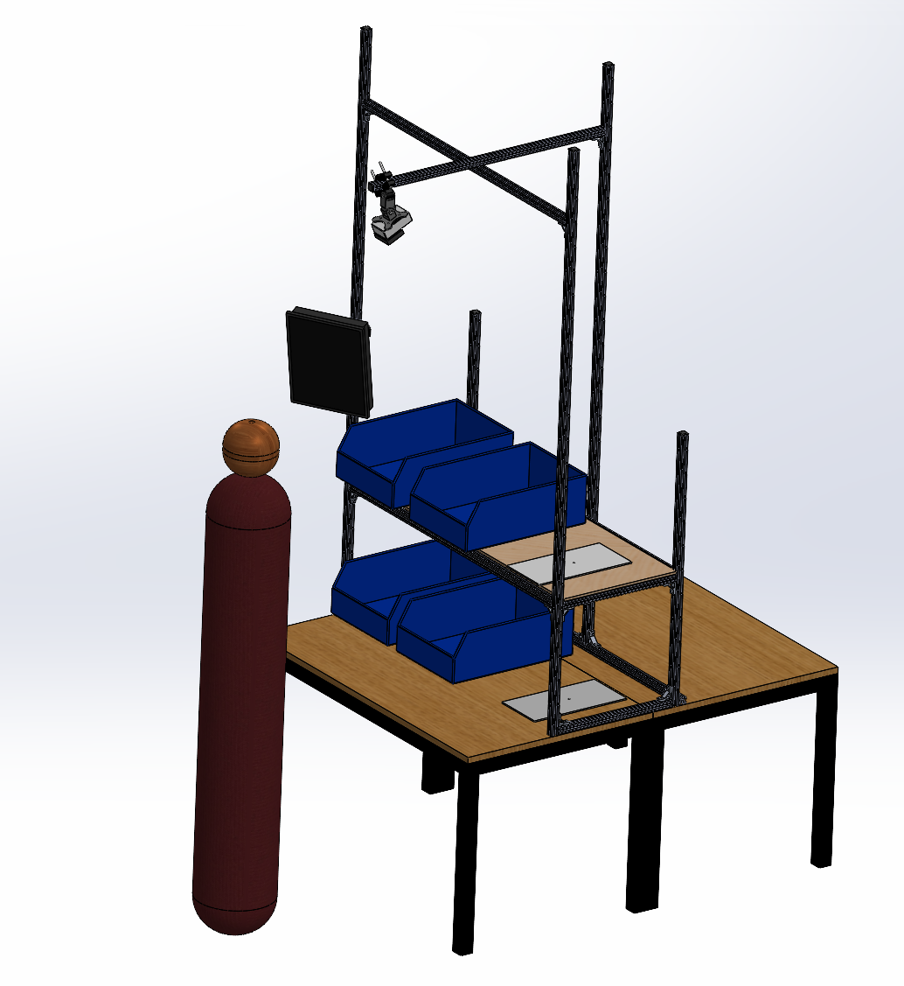
Figure 3.1.1: CAD model of the camera mount and structural frame

The workstation area is organized into (but not restricted to) a modular 2-layer, 6-grid-space layout. This grid enforces a systematic layout rule where larger inventory bins that span 2 grid spaces are designated for the bottom row, while small and medium bins that span 1 grid space occupy the top row, aligning with standard industrial manual material handling guidelines which prioritise placing smaller items in the primary reach zone while reserving lower tiers for bulkier containers.
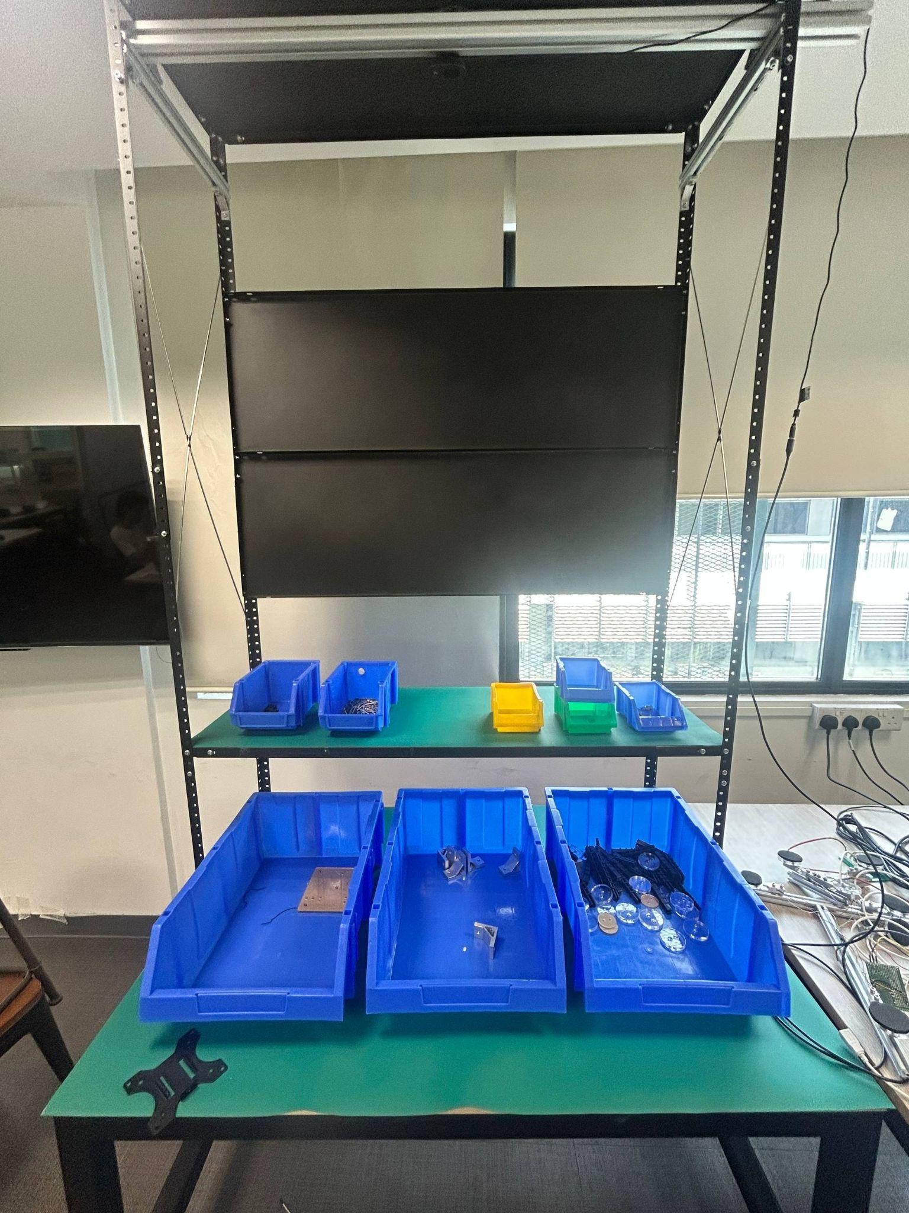
Figure 3.1.2: Configurable two-tier, 6-grid space bin layout
This physical structure integrates seamlessly into the environment. It ensures optimal camera visibility without requiring modifications to the existing workstation layout or the operator's natural workflow (D-08). Since the camera remains fixed, the overall working space is explicitly defined and invariant, allowing the computer vision model to reliably map spatial coordinates.

3.2 Sensor Subsystem

3.2.1 Computer Vision System

3.2.1.1 Requirements
The computer vision system is required to satisfy several functional requirements established in Chapter 1. It must identify which component type is present in each active kitting bin (D-01), a prerequisite for detecting wrong-part and missing-part errors (D-02, D-03). It must support efficient onboarding of previously unseen component types without requiring specialist machine learning expertise from plant engineers (D-07), and it must operate correctly under varying ambient lighting conditions without requiring modification to bin dimensions, colours, workstation layout, or operator workflow (D-08). Detection must additionally run at a speed sufficient to support real-time alerting within a timeframe that enables corrective action prior to kit completion (D-05), without negatively impacting per-kit cycle time (W-01).
These constraints directly shaped the architectural decisions described in the following subsections: the shift to a bin-centric rather than item-centric detection strategy (Section 3.2.1.2), the two-snapshot calibration process for onboarding (Section 3.2.1.3), and the selection of a lightweight hand-tracking framework over denser alternatives (Section 3.2.1.4).

3.2.1.2 Dynamic Bin Recognition
Initial prototyping demonstrated that training a deep learning model to recognize specific inventory parts was unfeasible due to the vast, evolving product catalog. Instead, the strategy shifted to a bin-centric architecture, combining bin-level detection with systematic assignments of specific items to bins. By decoupling the visual detection logic from the physical appearance of internal items, this strategy ensures the system remains robust against changing component mixes (D-01) and supports configuration-driven SKU onboarding (D-07).
To map these physical bins into digital zones, Horizontal Bounding Boxes (HBB) were selected because they eliminate edge contour noise, minimize computational overhead, and maintain strict axis-aligned tracking zones. The resulting box coordinates provide a highly stable area label per bin, establishing the geometric baseline required for fast and accurate downstream hand-in-bin validation (D-05).
To successfully deploy this YOLO-HBB model, two critical operating protocols were established. First, to ensure the model mathematically learns to ignore internal components, a strict training data collection protocol was developed for plant engineers [Appendix D]. This protocol enforces systematic variation of bin positions, fill levels (0% to 100%), and internal item layouts during image capture, forcing the model to lock exclusively onto the static bin rim, evolving the bin-centric model to rim-centric.
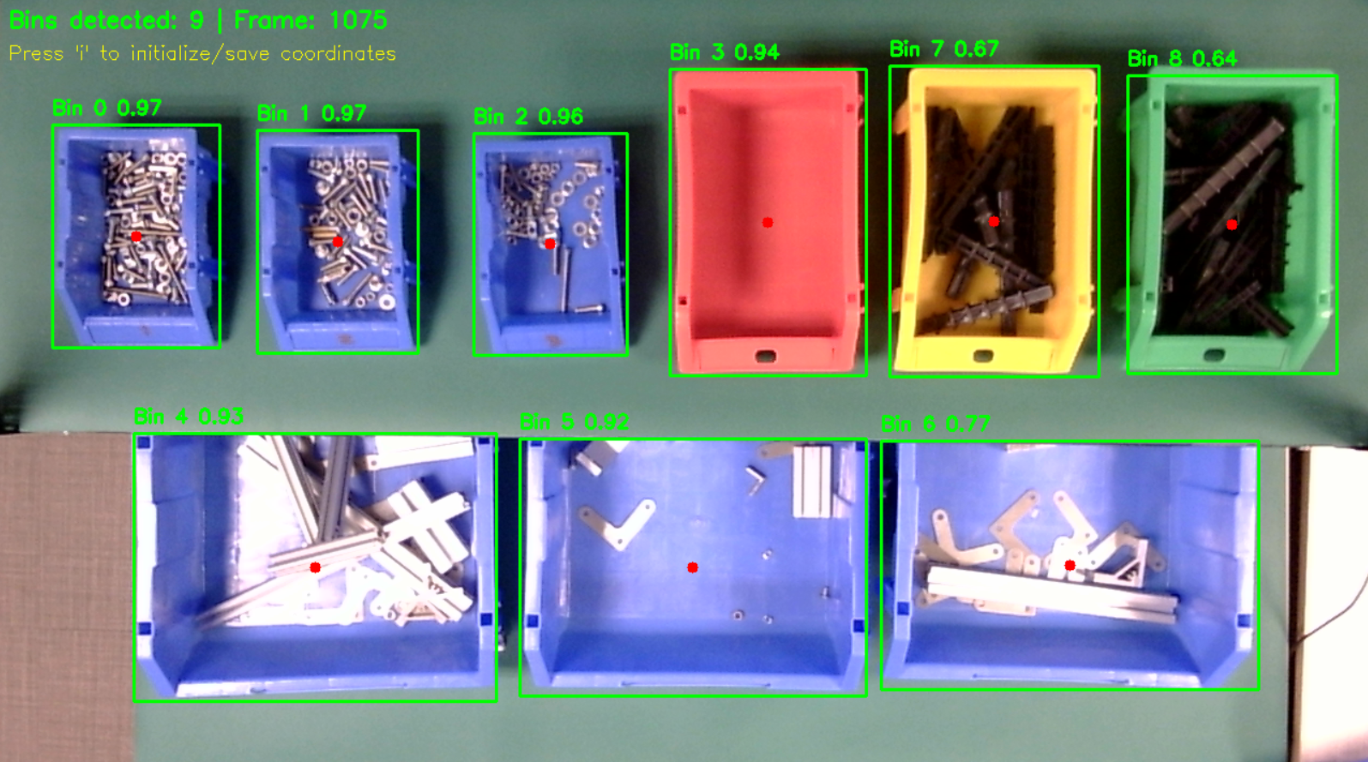Figure 3.2.2.1: Rim-centric bin detection. Horizontal Bounding Boxes (HBB) successfully lock onto the physical bin rims while ignoring internal component variations
Additionally, to prevent bin boundary distortion during the initialization phase caused by item occlusion, a strict physical constraint requires that bins are never filled past their top rims. By maintaining undistorted, highly accurate bin boundaries, the system can reliably determine exactly which bin the operator is interacting with. This accuracy is essential for providing precise corrective guidance (D-06). Enforcing this physical constraint keeps the deep learning model lightweight and simple, ensuring the system remains easily replicable and deployable across different workstations without extensive re-training (W-03).

3.2.1.3 Dynamic Grid Calibration and Initialisation
To satisfy the requirement for efficient new part onboarding (D-07), the system initializes using a dynamic two-snapshot calibration process. Rather than manually measuring and programming bin coordinates, which would require external specialists, the system first maps the physical grid slots, and then takes a second snapshot to register which slots contain active bins. This automated setup empowers plant engineers to configure the workstation independently (W-03). These recognized bins are then locked as permanent HBB geofences for the duration of the operational session. This establishes a stable, relative spatial mapping, providing the necessary digital coordinates required for downstream order integration and bin assignment (FR-07).

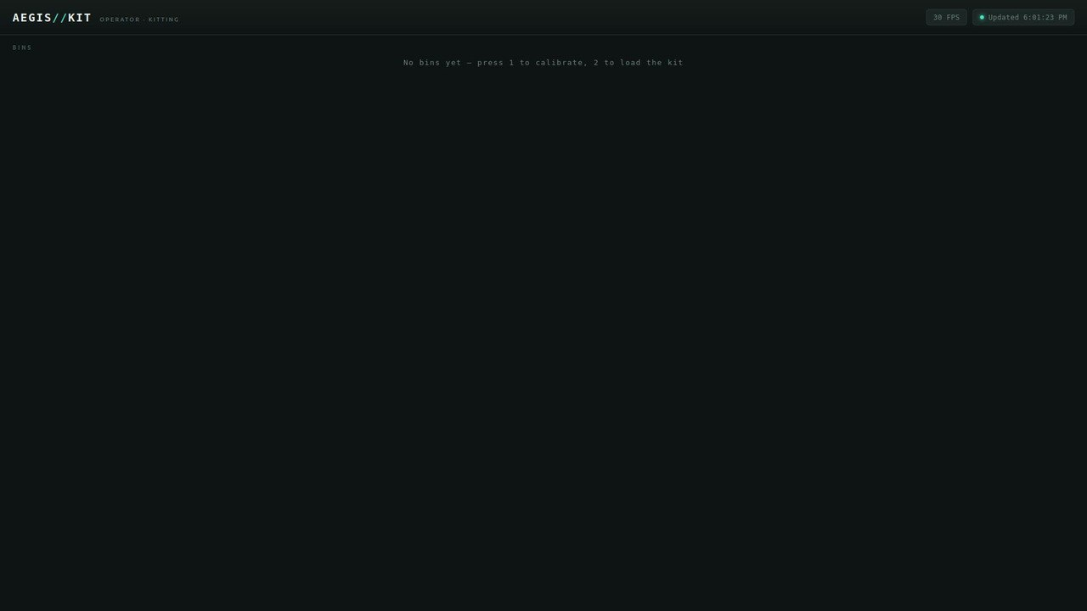
Figure 3.2.3.1: Dynamic grid calibration sequence start
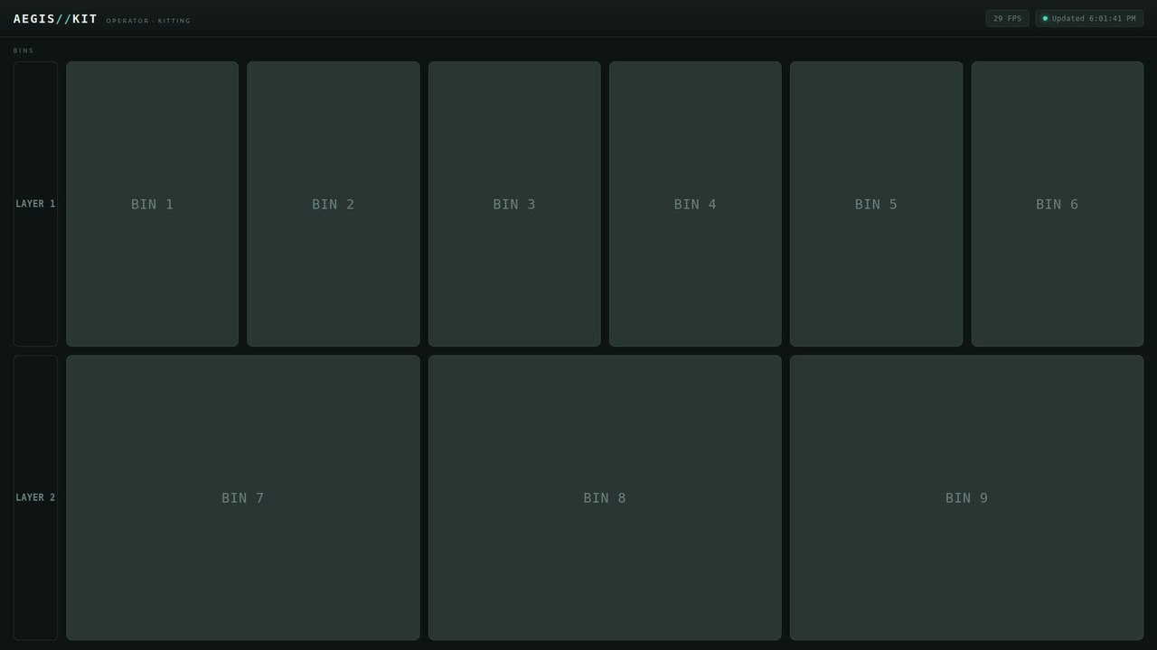
Figure 3.2.3.2: After first screenshot (registration of possible bin positions)
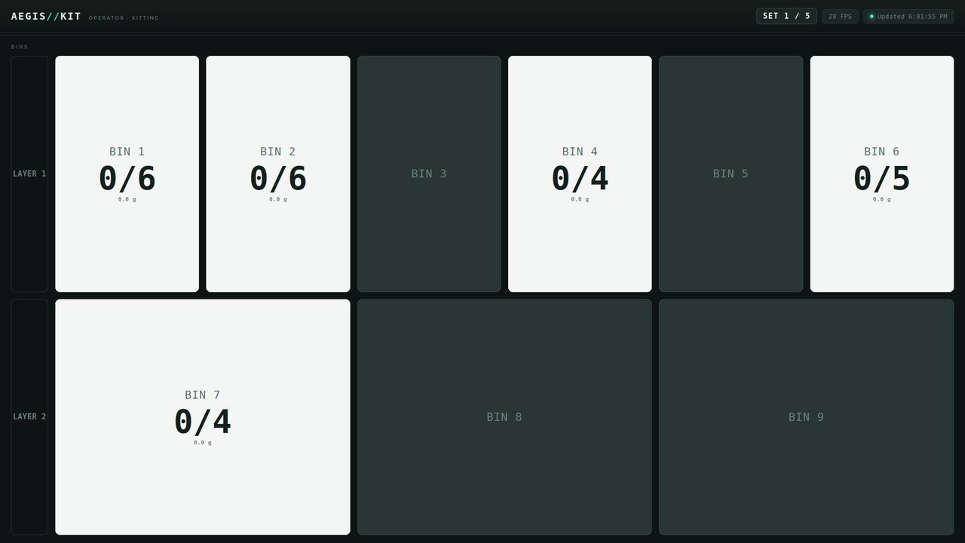
Figure 3.2.3.3: After second screenshot (registration of all active bin geofences)

3.2.1.4 Hand-Pose Model
The system utilizes the Google AI Edge MediaPipe Tasks Hand Landmarker for real-time, on-device tracking of 21 3D hand landmarks. By performing all processing locally on the Jetson Orin edge device, the architecture inherently satisfies strict data security and compliance requirements (W-04).
Running at approximately 30 frames per second, this framework avoids the heavy computational cost of dense pixel segmentation. This low-latency performance enables immediate, real-time alerting (D-05) without forcing the operator to pause, ensuring that per-kit cycle times are not negatively impacted (W-01). Furthermore, the efficiency of the landmarker leaves sufficient processing headroom to support future multi-workstation scalability on the same hardware (D-10). Ultimately, focusing on precise digit tracking rather than ambiguous bounding boxes provides the spatial accuracy needed to reliably pinpoint operator interactions.
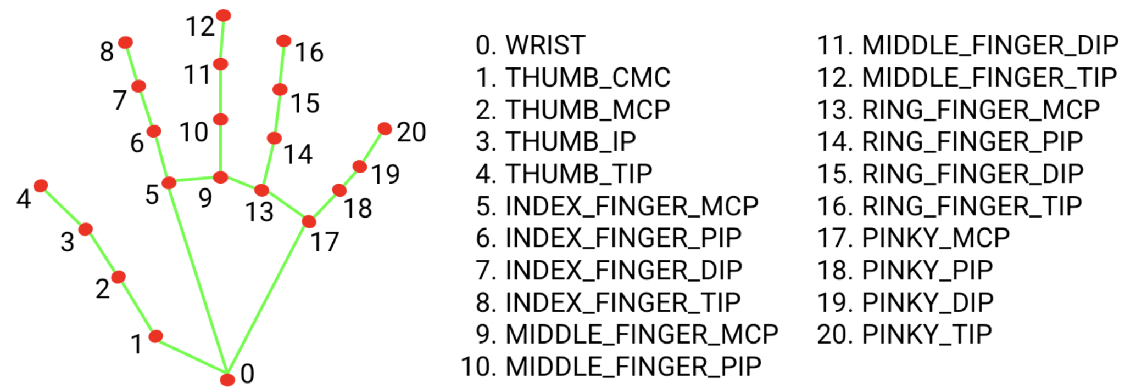
Figure 3.2.4.1: MediaPipe 21-point hand landmark topology
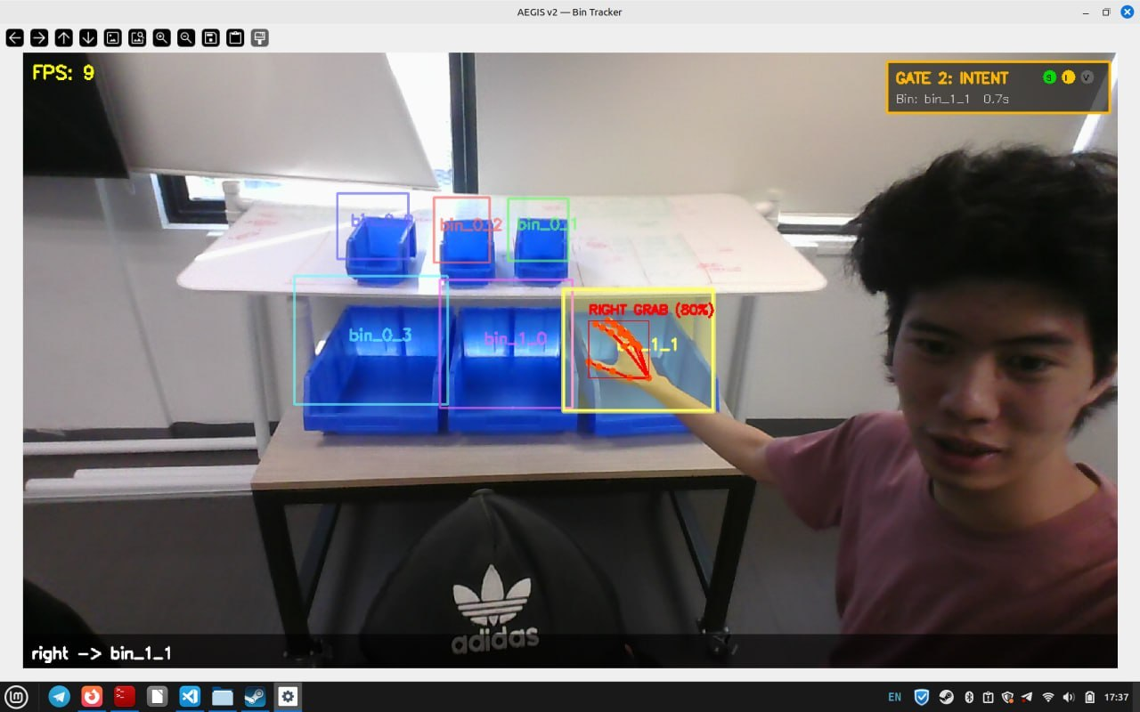
Figure 3.2.4.2: In-process landmark extraction during a live picking motion at workstations.

3.2.1.5 Spatial Bin Assignment
To translate hand landmarks into a definitive spatial location, the system employs a finger-voting algorithm focused exclusively on the index (landmark 8) and middle (landmark 12) fingertips. By filtering out other fingers, the algorithm accommodates natural tripod-grasp picking motions. This ensures the system does not require modifications to the operator's workflow (D-08), thereby preserving natural picking speed.
The locked bin boundary containing a fingertip receives a spatial vote. If the fingers split across adjacent bins, a deepest-penetration tiebreak evaluates the interiority distance, awarding the assignment to the finger planted deepest into a bin. This precise spatial resolution is critical for accurately identifying which component the operator is retrieving (D-01), ensuring highly reliable wrong-part error detection (D-02) even when hands straddle tight bin boundaries.

3.2.1.6 Occlusion Gating and State Hold
To maintain spatial accuracy across the two-tiered workstation layout, an Occlusion Gating mechanism and a stateful Occlusion Hold module serve as inline verification layers downstream of raw finger-voting. While finger-voting resolves spatial placement under clear line-of-sight conditions, upper-shelf overhangs introduce camera blind spots during lower-tier picks.
To adapt to upper-shelf camera blind spots, the Occlusion Gate computationally validates top-tier landmark predictions against proximal hand anchors and local pixel evidence before committing a bin event to the FSM. Complementarily, the Occlusion Hold module maintains state continuity for active bottom-bin picks when fingertips vanish behind shelf edges. Together, these modules aggressively filter out false extrapolation alarms. This ensures that real-time alerting (D-05) delivers strictly accurate corrective guidance (D-06) and reliably flags only genuine wrong-bin anomalies (D-02), thereby preventing false-positive interruptions that would otherwise degrade per-kit cycle time (W-01). A detailed breakdown of the physical extrapolation failure mode, the iterative development of the gate, and unit test validation is presented in Section 3.2.1.7.

3.2.1.7 Design Validation
As mentioned in Section 3.2.1.2, the computer vision pipeline utilizes Horizontal Bounding Boxes (HBB). To arrive at this optimal design, a comparative evaluation of three distinct boundary tracking methods was conducted.
To accurately track which bin a hand is in, the system must map the physical bins into stable digital zones. The computer vision model cannot rely on the internal inventory items, as they constantly shift, stack, and change shape. To prevent the system from getting confused by the contents, the boundary recognition needed to focus exclusively on the physical bin rim.
Instance segmentation (Mask R-CNN) and Oriented Bounding Boxes (OBB) were initially tested to map the bins. However, segmentation masks proved highly unstable, as the masks would dynamically bleed over items protruding past the rim, creating jagged, hallucinated edges. OBB successfully stabilized the boundaries, but evaluating angular rotation added unnecessary computational overhead, since the physical workstation frame already enforces a strict orthogonal grid.
To achieve the best balance of stability and processing speed, the system was finalized on Horizontal Bounding Boxes (HBB). HBB completely eliminated edge contour noise and minimized processing overhead by ignoring unnecessary rotational data. Furthermore, by locking tightly onto the rectangular blue rim of the bin rather than its contents, HBB provided the strict, axis-aligned tracking zones required for the downstream finger-voting algorithm to function accurately (Section 3.2.1.5).
Validation & Impact: By selecting HBB, the vision pipeline maintained highly stable spatial labels across all tested fill levels and lighting conditions. This ensured the system provided the precise geometric baseline required for real-time hand-in-bin validation, successfully satisfying the alerting requirements (D-05).
As mentioned in Section 3.2.1.6, the Occlusion Gate and Occlusion Hold are used to filter out tracking errors. These modules were developed iteratively to fix a major issue discovered during integration testing.
When operators reached into the bottom row of bins, the physical shelf lip blocked the camera's view of their fingers. Because it couldn't see the fingers, the MediaPipe model would guess their location and incorrectly extrapolate the fingertips into the top-row bins. This caused the system to trigger false "Out-of-Sequence" and "Wrong-Bin" alarms (D-02).
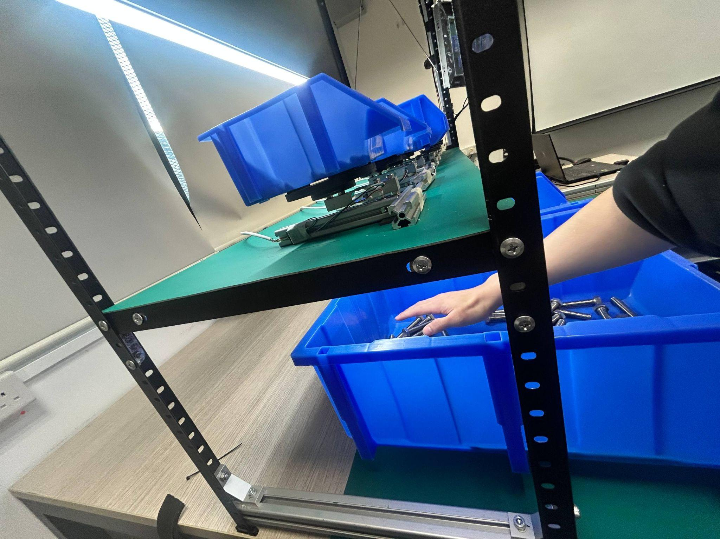
Figure 3.2.7.1: Side-view schematic showing the shelf lip occluding fingertips during a bottom-bin reach.
The first attempt to fix this involved checking the height of the wrist and knuckles against the shelf rim. However, this method was too sensitive to normal hand movements. It also broke when MediaPipe incorrectly swapped left and right hand labels while the hand was hidden. To build a more reliable solution, the software was updated to use a background-subtraction model (MOG2) to verify actual pixel data:
- Foreground-Evidence Gate: When the system detects a hand in a top bin, it now checks if there are actual foreground pixels at the fingertip location. If the pixel presence is below 20% (present_ratio < 0.20), the system knows the top-bin hit is a mistake and corrects the assignment down to the bottom bin.
- Bin-Keyed Occupancy Hold: Sometimes the hand disappears completely behind the shelf lip. To handle this, the hold module was redesigned to track the physical bin area instead of the specific hand. The bottom bin remains "active" as long as the operator's forearm is detected inside the bin (occupied_bins). The system releases the bin the moment the arm is pulled out, rather than relying on a static timer.
This new logic was tested using 34 automated unit tests (22 for the gate with 83% coverage, and 12 for the hold with 100% coverage). During final integration testing with six different operators, this solution successfully eliminated all false top-bin alarms and met the real-time verification requirements (D-05, D-06).
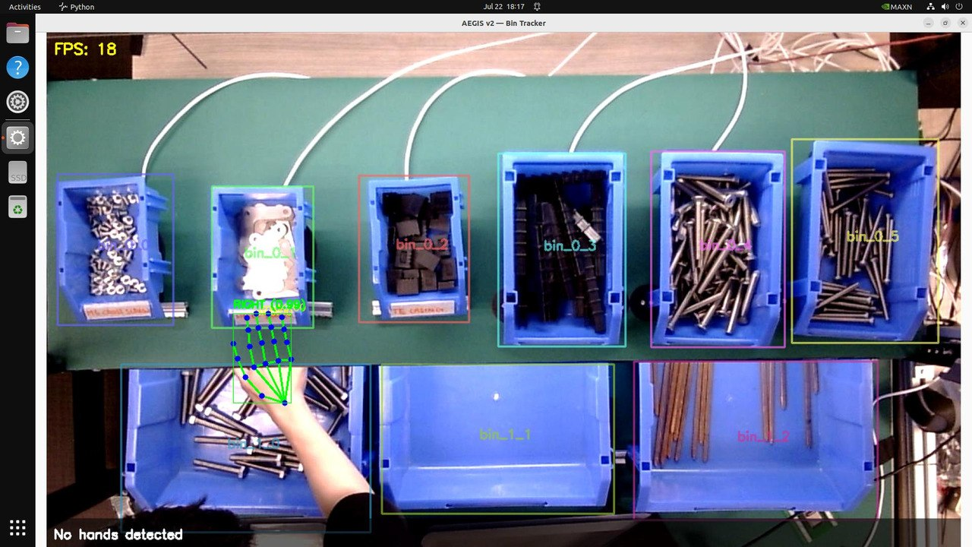
Figure 3.2.7.2: With the gate — proximal anchor detection overrides to the correct bottom bin.

3.2.2.1 Requirements
The load cell system is required to satisfy the quantity-verification requirement established in Chapter 1: the system shall verify that the quantity of each component placed into the kit matches the quantity specified in the order (D-04). This requirement exists because quantity errors — too few or too many items picked — are not reliably detectable by computer vision alone, and gravimetric sensing was identified as the complementary modality capable of resolving them (Section 1.9).
The platform design must additionally support components across a wide range of unit masses and bin sizes without requiring the operator to alter their picking workflow (D-08), and must remain mechanically stable under freehand loading, since instability directly compromises the accuracy of the quantity signal the FSM depends on (Section 3.3.3). As established in Chapter 2 (Design Selection), load cells were selected as the measurement method because no other approach could reliably identify component quantity on a consistent basis; this decision was further supported by the availability of a TE component database containing reference weights and specifications for each item, allowing measured mass to be matched against known values for verification.

3.2.2.2 Frame Design
The initial design consisted of a simple cantilever platform, with the load cell secured by screws and the item rest formed from bolts. However, the bolted arrangement proved unstable and required items to be placed directly onto the load cell, which was impractical for routine use.
The second iteration introduced a circular acrylic platform to improve stability. While this allowed a small bin to be seated securely, it remained prone to tipping when the bin's contents shifted to one side, displacing the centre of gravity beyond the platform's stable region. The resulting final design for small bins was a circular disk of [X] cm in diameter, which provided adequate stability for the expected load distribution.
The resulting final design for small bins was a circular disk of 12 cm in diameter, which provided adequate stability for the expected load distribution.
Larger bins presented an additional challenge. Their greater footprint required a correspondingly wider platform, but single-point load cells maintain rated accuracy only within a specified distance from their centre; off-centre loading beyond this range introduces measurement error. A larger single-cell platform would therefore improve stability at the expense of accuracy. This trade-off, and its resolution via a three-load-cell configuration, is addressed in Section 3.2.2.3.

3.2.2.3 Cell Configuration
To resolve the stability–accuracy trade-off introduced in Section 3.2.2.2, a three-load-cell configuration was adopted for larger bins. Distributing the load across three points ensured that the bin's centre of gravity always fell within the triangle formed by the cells, providing both mechanical stability and accurate readings. Three cells were chosen over four because a three-point arrangement guarantees simultaneous, full contact between all cells and the platform on any surface, whereas a four-cell layout is statically over-constrained and can leave one cell under-loaded if the surface is not perfectly flat.
Furthermore, the three-load-cell configuration allowed for scalability to fit the dimensions of any bins the factory uses, by simply ensuring that the three points of contact remained within the off-centre loading limit.
Finally, the system's weight constraints must account for load cell resolution. A load cell's accuracy is specified as a percentage of its rated maximum capacity, with the capacity indicated by its designation: a 1 kg load cell has a maximum capacity of 1 kg and a nominal error of ±0.5 g, while a 5 kg load cell has a maximum capacity of 5 kg and a correspondingly larger nominal error of ±2.5 g. As a result, a higher-capacity cell trades absolute resolution for a greater usable range. In testing, however, the 5 kg load cells arranged in the three-cell configuration achieved an error of ±0.5 g, comparable to that of the 1 kg unit, as the distributed arrangement reduces the load borne by each individual cell.
Because all load cells share the same physical design and form factor, they are mechanically interchangeable, allowing the appropriate capacity to be selected according to the expected item weight without modification to the platform. The required capacity is therefore driven by two factors: the weight of the components being measured and the maximum permissible weight of the bin. By industry standards, a single bin may not exceed 25 kg, with a typical "heavy" bin falling in the 10–15 kg range, which informs the upper bound of the load cell capacity required for the larger platforms.

3.2.2.4 Design Validation
Bench testing revealed that a single cantilever load cell could not support larger bins without tipping, while expanding the platform on a single-point cell introduced extreme off-centre measurement errors (Section 3.2.2.2).
The platform was redesigned as a three-point summed load cell triangle for medium and large bin configurations (Section 3.2.2.3). This configuration stabilises the centre of gravity within the support triangle while the HX711 summation circuit maintains a single-channel interface to the microcontroller, preserving full software compatibility.
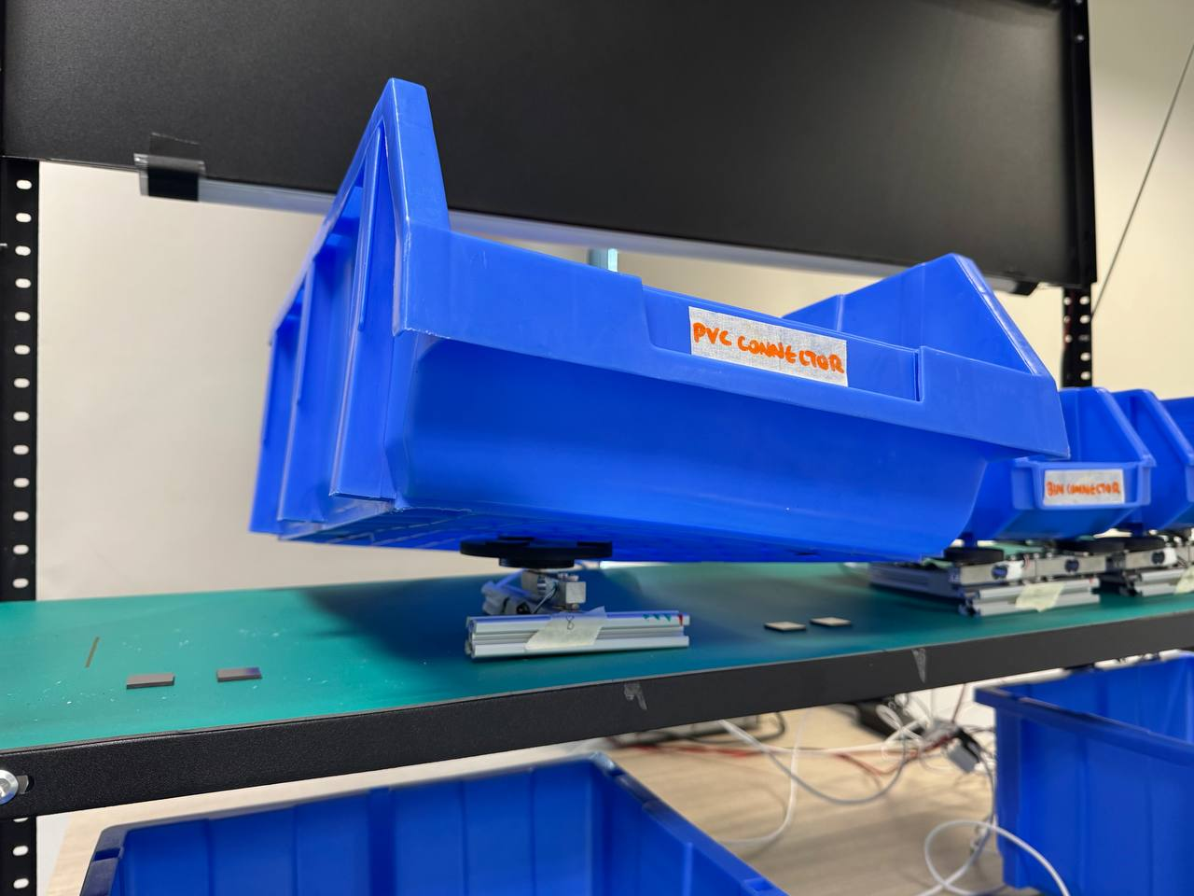
Figure 3.2.2.4.1: Initial single-cell cantilever platform exhibiting tipping instability.
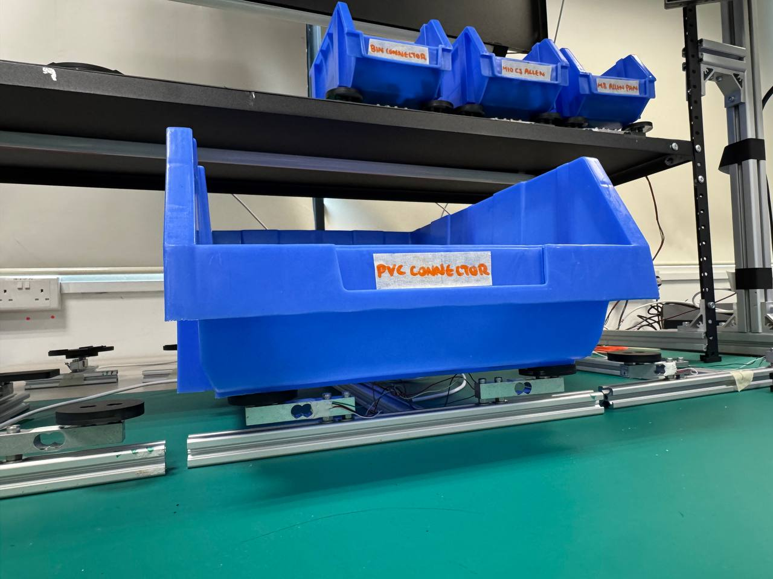
Figure 3.2.2.4.2: Final three-point triangle configuration with stable bin seating (front)
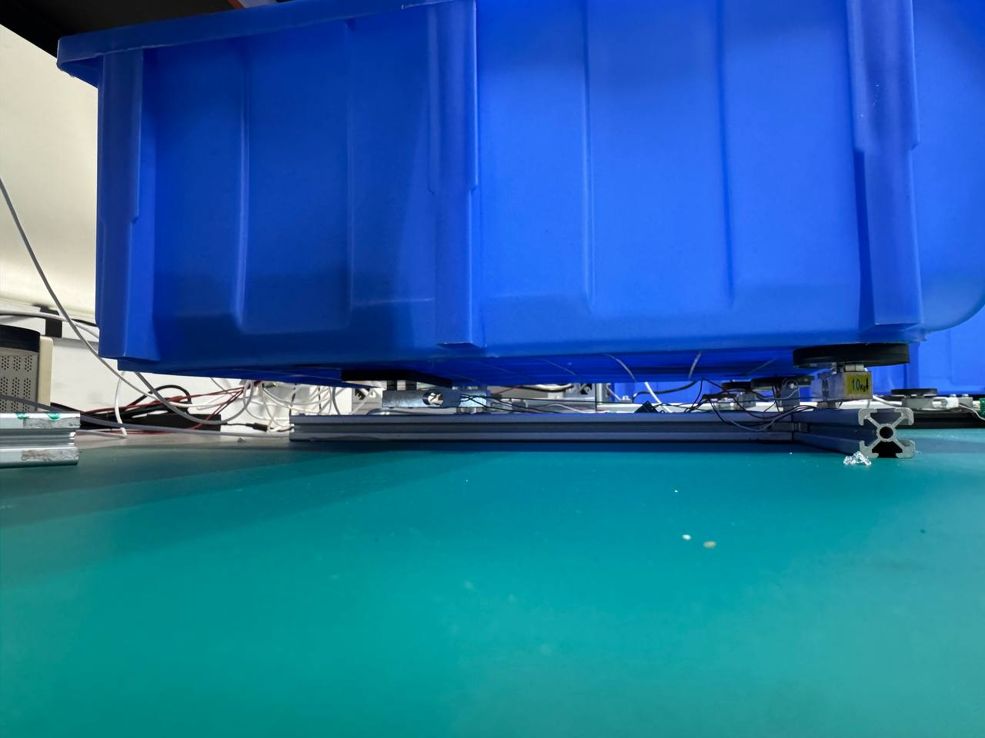
Figure 3.2.2.4.3: Final three-point triangle configuration with stable bin seating (side)

3.3 System Software

3.3.1 Software Stack Specification

3.3.1.1 Requirements
The software stack is required to satisfy the data security constraint established in Chapter 1: all system processing must be performed on-device, with no production data transmitted to external networks (W-04). It must additionally support deployment and configuration by plant engineers without requiring external specialists or specialist cloud infrastructure (W-03), and must decouple the computationally heavy computer vision inference loop from load cell polling and the user interface, so that sensing throughput is not constrained by HMI refresh timing (Section 3.2.1.4, D-05). These constraints directly shaped the selection of an entirely on-device, edge-deployed architecture described in Section 3.3.1.2.

3.3.1.2 Iteration
[CONTENT NEEDED — no source material in current draft: the current draft presents the software stack specification (Jetson AGX Orin, Python core logic, asynchronous IPC, FastAPI backend) as a single finalised architecture, with no account of intermediate iterations, alternatives considered, or the reasoning by which the current stack was arrived at. Unlike the load cell platform (Section 3.2.2) or the bin boundary representation (Section 3.2.1.7), no iteration narrative for the software stack exists elsewhere in the draft to reorganise here.]

3.3.1.3 Design Validation
The software architecture is designed for secure, low-latency, edge-deployed execution. All processing runs entirely on-device via an NVIDIA Jetson AGX Orin, ensuring strict compliance with production data sensitivity requirements by eliminating the need for external network transmission (W-04). The core logic is built in Python, utilizing asynchronous Inter-Process Communication (IPC) to decouple the heavy computer vision inference loop from the load cell polling and user interface web server. A FastAPI backend serves the frontend application locally, ensuring the system can be deployed and configured by plant engineers without requiring specialist cloud infrastructure (W-03).
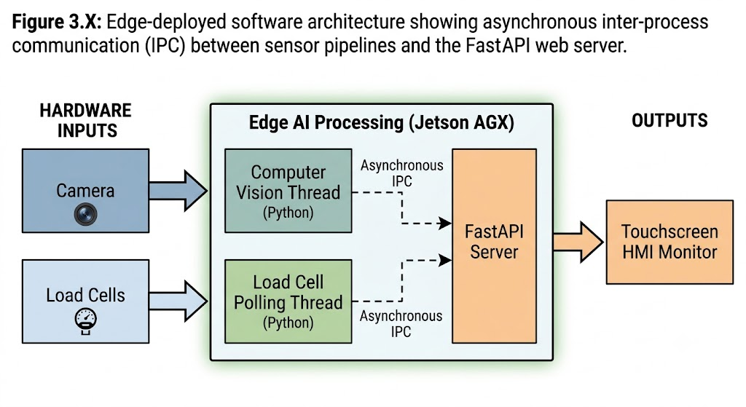
Figure 3.3.1.3.1: Software architecture between sensor pipelines and FastAPI web server.

3.3.2 Frontend HMI

3.3.2.1 Requirements
The frontend HMI is required to render a spatial layout mirroring the physical grid so that bin assignments read intuitively to the operator (FR-07), and to guide the operator through the required workflow without adding manual handling steps (D-04). Upon error detection, the interface must transition to an active alert state within sub-second latency (D-05) and deliver corrective guidance that is specific to the location and nature of the error (D-06), requiring the operator to physically correct the mistake before the kitting sequence is permitted to advance.

3.3.2.2 Iteration
The frontend subsystem operates on a touchscreen monitor at the kitting workstation, synthesizing computer vision coordinates and active order metadata. To establish an intuitive baseline, it renders a 2D spatial layout mirroring the physical grid (FR-07).
To guide the operator through the required workflow without adding manual handling steps (D-04), the UI non-invasively highlights only the current target bin, indicating that the operator must pack sufficient items from this bin before moving on. During correct picking sequences, when the operator's hand enters the active bin, the UI renders a green outline over the bin to confirm a valid interaction. Once the required quantity for that component is completely fulfilled, the bin indicator turns fully green.
Upon an error trigger, the interface dynamically transitions to an active alert state within sub-second latency (D-05). If an operator reaches into an unprescribed bin, a red cross is rendered directly over the erroneous bin on the UI, delivering immediate, location-specific corrective guidance (D-06). The interface requires the operator to physically correct the mistake before the system allows the kitting sequence to advance.
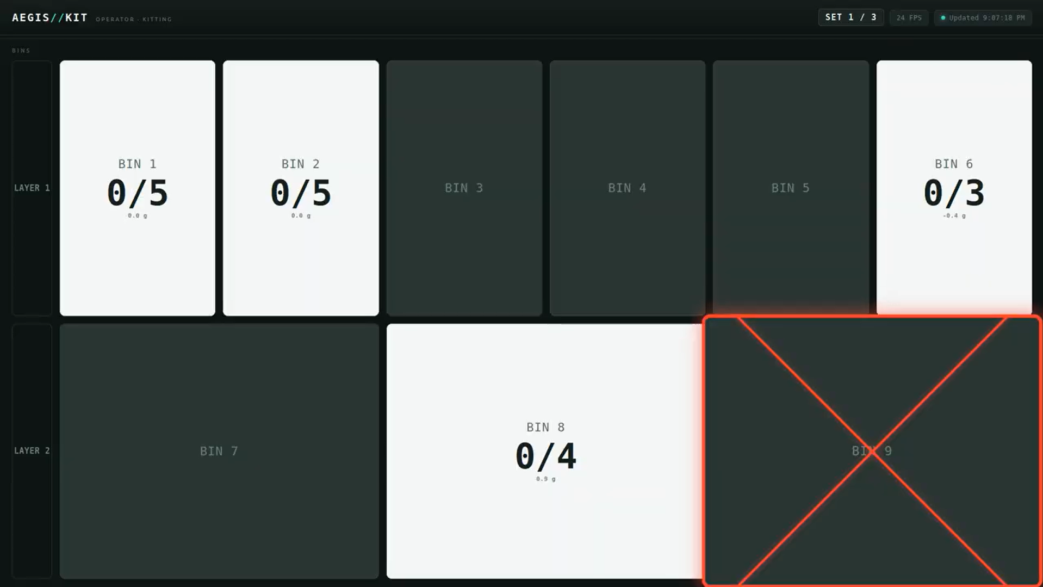
Figure 3.3.2.2.1: Red outline — hand over the wrong bin.
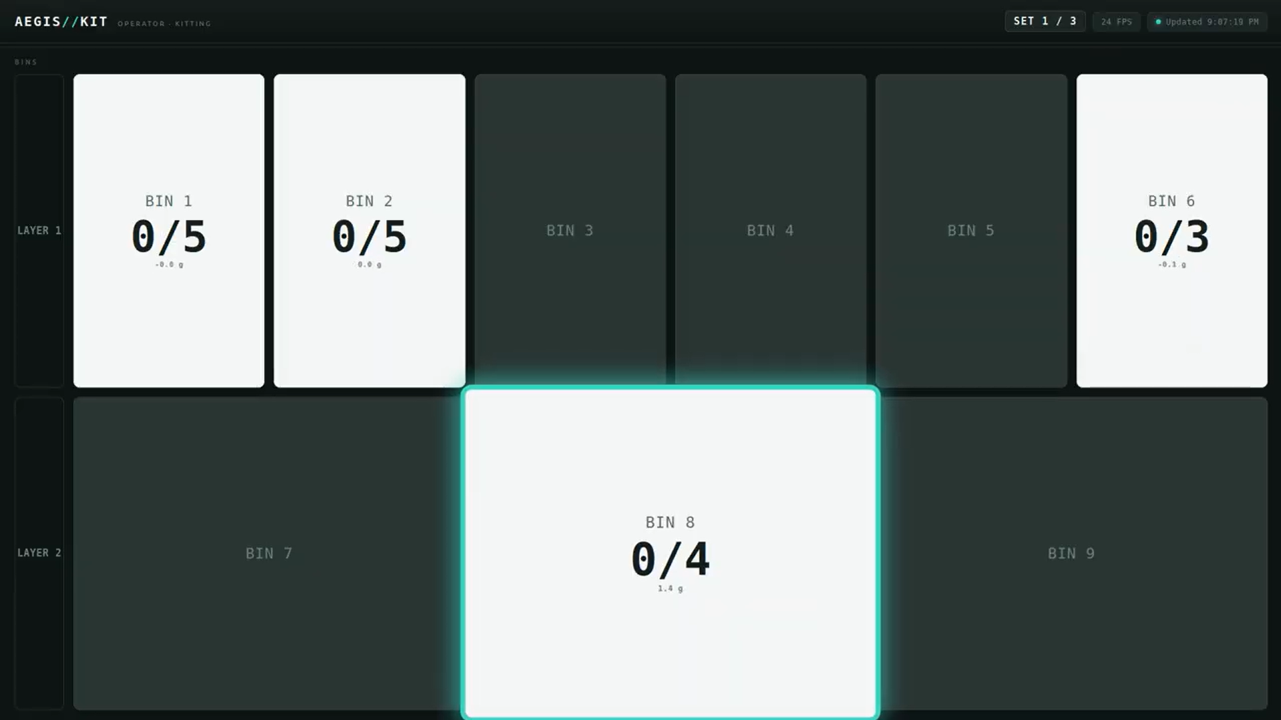
Figure 3.3.2.2.2: Green outline — hand in the correct bin.
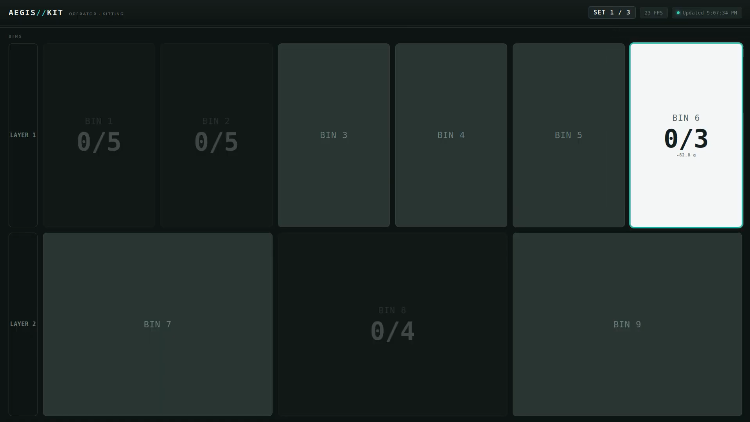
Figure 3.3.2.2.3: Target state — only the working bin is active.
This subsection should additionally incorporate the HMI iteration driven by usability findings — the six gaps (G1–G6) identified in operator feedback and the corresponding changes mapped in old Table 5.4 — carried forward from the old draft's Section 5.2. [CONTENT NEEDED — placement note: the ground-rules content summary assigns this material to 3.3.2.2, but its natural chronological position is after the developer testing and user testing phases described in Chapters 4 and 5, since it responds to usability gaps only surfaced during user testing (old Section 5.1.2). Reproducing it here would require presenting the iteration before the findings that motivated it are introduced. Recommend either: (a) leaving a forward cross-reference here and fully placing the G1–G6 iteration content in Chapter 5 (old Section 5.2's original location), or (b) confirming you want it duplicated/summarised in both places. Flagging for your decision rather than silently choosing.]

3.3.2.3 Design Validation
[CONTENT NEEDED — no source material in current draft: the current draft does not present a separate validation discussion for the frontend HMI at the design stage distinct from the iteration narrative in 3.3.2.2 above. The closest related validation evidence — operator usability ratings (R1–R9) and the TE Connectivity stakeholder's qualitative feedback on the UI — is user-facing, post-integration testing data, and is assigned in the chapter mapping to Chapter 5 (Sections 5.3/5.4) rather than to this design-validation subsection.]

3.3.3 Backend Processing Engine

3.3.3.1 Requirements
The backend processing engine is required to ingest hand-landmark tracking and load-cell mass data in real time and evaluate them against pre-loaded order rules (FR-07). It must enforce detection of wrong-part placement (D-02) and missing-part conditions at kit completion (D-03), derive quantity counts from passive weight changes so that new component types can be onboarded by updating configuration data alone, without requiring model retraining (D-07). It must additionally expose logged state transitions and fault events so that supervisory personnel can obtain visibility of kitting status without physically attending the workstation (D-09), and its architecture must support extension to multiple concurrent workstations without fundamental redesign (D-10).

3.3.3.2 Iteration
[CONTENT NEEDED — no source material in current draft: as with the software stack specification (Section 3.3.1.2), the current draft presents the backend processing engine's finite state machine as a single finalised design, with no account of intermediate iterations or alternative approaches considered prior to arriving at the sequential single-bin FSM architecture described in Section 3.3.3.3. No iteration narrative exists elsewhere in the draft to reorganise here.]

3.3.3.3 Design Validation
Operating as an asynchronous background service, the backend ingests 30 FPS hand-landmark tracking and continuous load-cell mass data into an in-memory state repository. The core decision logic is governed by a deterministic Finite State Machine (FSM) that evaluates these incoming sensor streams against pre-loaded order rules.
Crucially, the FSM enforces a sequential single-bin kitting workflow. It requires the operator to fulfil one specific component type at a time, keeping only one bin "active" in the system state. As the operator picks items, the FSM evaluates signed mass deltas from the load cells against the component's unit weight to track the quantity picked (D-04). Once the target count is reached, the FSM marks the component as complete and sequentially activates the next bin in the order.
The FSM continuously tracks this progression and actively flags fault states. If an operator accesses any unprescribed bin while an active bin is still incomplete, the FSM immediately triggers a Wrong-Bin or Out-of-Sequence state (D-01, D-02). Upon order completion, the FSM verifies that all required SKU quantities across all sequence steps have been satisfied before authorizing kit sign-off, ensuring strict missing-part detection (D-03). Because the architecture derives pick counts directly from passive weight changes, new component types are onboarded seamlessly by simply updating the configuration database with the new SKU identity and unit mass (D-07).
Furthermore, because the backend continuously logs these FSM state transitions and fault triggers, the data can be queried over the local network to provide real-time dashboard visibility to supervisory personnel without requiring them to physically attend the workstation (D-09).

3.4 System Integration

3.4.1 Requirements
System integration is required to bring the independently prototyped computer vision, load cell, and HMI subsystems (Sections 3.2–3.3) together into a unified real-time pipeline, following the system architecture established in Chapter 2. The integrated pipeline must maintain the frame-rate performance of the sensing subsystems independently of HMI refresh timing, so that neither computer vision inference nor load cell polling is bottlenecked by interface rendering (D-05, W-01). This requirement directly motivated the decoupled orchestration architecture described in Section 3.4.2.

3.4.2 Iteration
The integration of the system directly follows the system architecture diagram established in Chapter 2. A central pipeline orchestrator was developed to coordinate the real-time data flow between the computer vision, load cell, and HMI subsystems, bringing the isolated components together into a unified architecture.
The physical deployment of the AEGIS prototype brings together the structural CAD designs from Section 3.1 into a fully realised workstation. The complete setup features the overhead camera mount, the integrated load-cell receptor platform beneath the bins, and the operator-facing HMI dashboard. This integrated environment allows for seamless testing of the combined computer vision and weight-sensing pipeline.
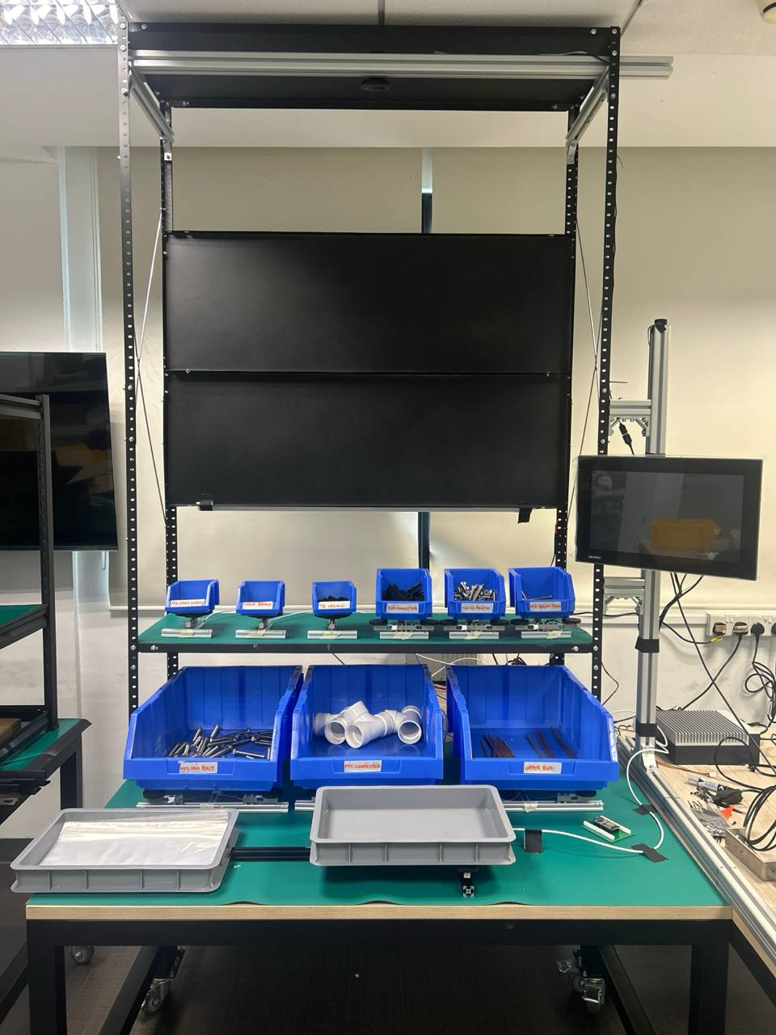
Figure 3.4.2.1: Fully integrated AEGIS workstation setup, transitioning from the CAD model to the physical prototype.
Once initialised, the real-time processing loop executes continuously. Each frame follows a fixed sequence: camera capture, hand tracking, bin assignment, weight delta evaluation, FSM state update, and HMI refresh.
The CV and load cell threads write to a shared PipelineState object, while the FastAPI web server reads from it independently. This decoupling ensures that the sensing loop runs at full frame rate regardless of HMI refresh timing.
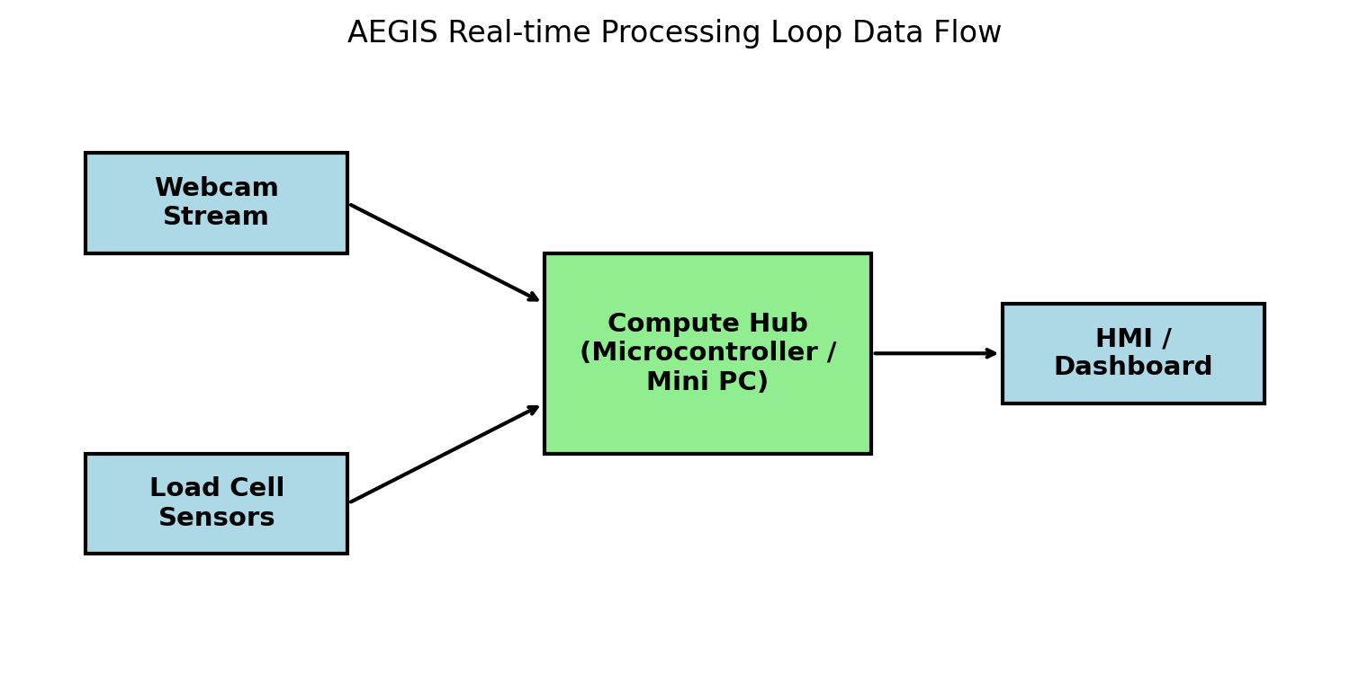
Figure 3.4.2.2: Real-time processing loop data flow diagram.

3.4.3 Design Validation
Integration testing confirmed that the decoupled architecture successfully achieved full-frame-rate sensing independent of HMI refresh, maintaining an end-to-end latency below 80ms.

Chapter 4: Developer Testing and Validation

4.1 Computer Vision System

4.1.1 Test Results and Findings
The CV detector was evaluated using a layer-by-layer permutation protocol designed to test invariance to bin position, colour, and fill level. Testing proceeded across three setup groups, each isolating one variable.
Table 4.1.1.1: CV testing conditions
Group | Variable Tested | Conditions
A | Bin colour and layout | A1: 9 blue bins (baseline); A2: mixed red/green/blue/yellow; A3: blue + mixed set
B | Bin contents and fill level | 7 item categories at 3 fill levels (empty, partial, full). Items: matte connectors, reflective brackets, shiny screws, PVC pipes, copper rods, dark connectors, and mixed items
Lighting | Ambient illuminance | 8 levels from approximately 0 lux to 506 lux; 9 bins measured per level (72 readings total)

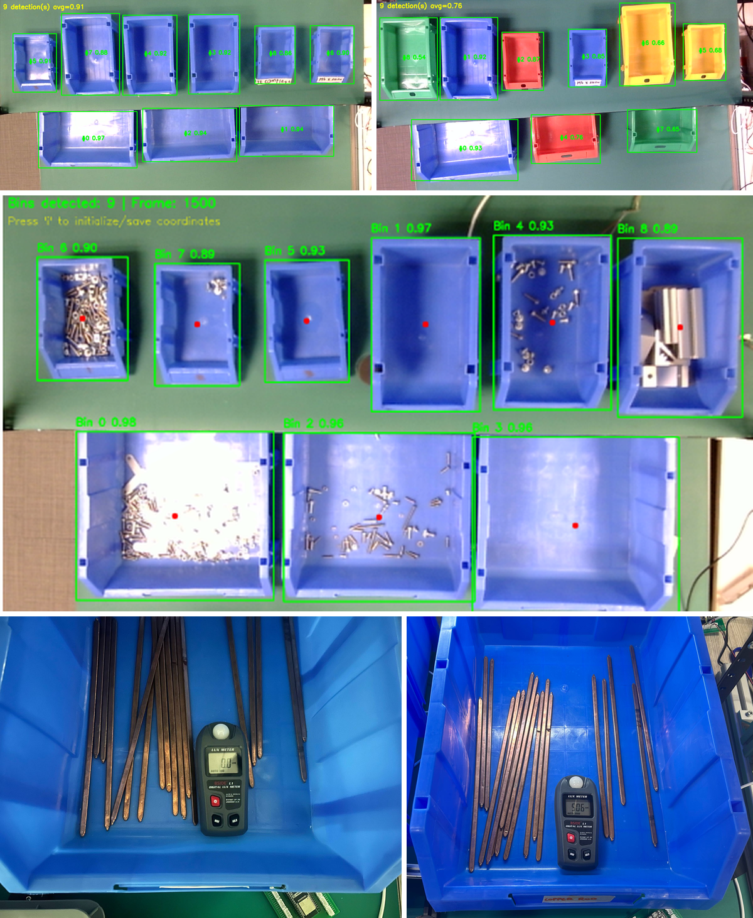
Figure 4.1.1.1: CV test setups. (a) Group A baseline with all blue bins. (b) Group A2 with mixed colours. (c) Group B with varied items at different fill levels. (d) Lighting sweep setup with lux meter.
Group A Results
Under condition A1 (all blue bins), the model achieved 100% detection across 20 sample frames. When non-blue bins were introduced under conditions A2 and A3, detection accuracy decreased to 80% and 85% respectively. Analysis of the failure cases revealed hallucinated bounding boxes when non-blue rims were present. This finding informed the decision to standardise on blue bins for the deployment configuration.
(Figure 4.4 inserted here)
Figure 4.4: Group A detection results. (a) A1: 100% detection. (b) A2: hallucinated bounding box example. (c) Accuracy comparison across the three conditions.
Group B Results
With standardised blue bins, detection is held at 100% across all seven item categories at every fill level, including copper rods protruding above the bin rim. This confirms that the model is rim-centric and content-invariant.
(Figure 4.5 inserted here)
Figure 4.5: Group B sample detections across item categories and fill levels.
Model Validation Metrics
The fullness-varied model (Setup V3) achieved the validation metrics shown below.
(Table 4.2 inserted here)
Metric | Value
Precision | 0.999
Recall | 1.000
mAP50 | 0.995
mAP50-95 | 0.935
Epochs | 55 (early stopping at epoch 54)
(Figure 4.6 inserted here)
Figure 4.6: Training curves for Setup V3, showing loss convergence and mAP over epochs.
Lighting Characterisation
Detection held at 100% across all 72 readings, including near-darkness at approximately 0 lux. Confidence correlated weakly with illuminance (Pearson r = 0.27 linear, r = 0.40 log-lux), and the trend was non-monotonic. The practical conclusion is that the rim-centric detector is not lighting-limited over the station's operating range.
(Figure 4.7 inserted here)
Figure 4.7: Lighting characterisation results. (a) Lux readings across 9 bins at 8 levels. (b) Confidence versus illuminance scatter plot. (c) Sample detections at approximately 0 lux and 506 lux.

4.1.2 Validation of Requirements
The evaluation results in Section 4.1.1 provide developer-phase validation of three functional requirements. Detection accuracy of 100% under the standardised blue-bin configuration (Group A1), combined with 100% content-invariant detection across all item categories and fill levels (Group B), supports D-01 (Component Identification): the system reliably identifies which bin — and by extension, which component type — is present at each position, independent of the bin's contents. The elimination of hallucinated bounding boxes under standardised bin colour directly supports the reliability of downstream wrong-part detection under D-02 (Wrong Part Detection), since a hallucinated or misplaced bin boundary would otherwise be a plausible source of false wrong-bin alarms independent of any actual operator error. The lighting characterisation result — 100% detection held across the full 0 to 506 lux range tested, with no meaningful degradation in accuracy — supports D-08 (Environmental Robustness), confirming the detector's operation is not lighting-limited over the station's tested operating range.
The mixed-colour degradation observed under conditions A2/A3 (80–85% detection) is not read as a requirements failure, since the deployment configuration was standardised on blue bins as a direct result of this finding; the requirement is validated against the standardised configuration the system is deployed under, not against the non-standard configuration used to characterise the failure mode.

4.2 Load Cell System

4.2.1 Test Results and Findings
The load-cell subsystem underwent a structured measurement-system qualification, conducted independently of the computer-vision and UI subsystems and prior to full-system integration testing. The qualification was structured across three tiers: Capability (whether the platform resolves the masses at stake), Stability (whether the reading holds over time), and Integration (behaviour under off-centre, freehand loading).
(Figure 4.8 inserted here)
Figure 4.8: (a) Pytest terminal output showing 134/134 tests passing. (b) Coverage report summary for the core verification modules.
(Table 4.3 inserted here)
Module | Statements | Coverage
placement.py (FSM core) | 196 | 98%
bin_assignment.py | 260 | 83%
occlusion_hold.py | 35 | 100%
grid_allocator.py | 107 | 93%
grid_calibrator.py | 79 | 96%
grid_session.py | 74 | 95%
inventory.py | 45 | 78%
cycle.py | 39 | 100%
Overall project | 2,569 | 50%
For the 5 kg and 10 kg platforms, three individual load cells share one rigid base and one bin, with bridge outputs summed in hardware ahead of the HX711 — each platform reports one combined weight, not three independent readings.
Load cell hardware. All cells are YZC-133 strain-gauge load cells (rated 1–10 kg depending on configuration), each platform paired with one HX711 24-bit ADC. The performance figures below are published by the component supplier; they are not corroborated by an independent manufacturer datasheet, and are used in this report only as an engineering reference point for interpreting measured results.
Table 4.2.1.2: Supplier-stated YZC-133 performance parameters — nonlinearity, hysteresis, repeatability, creep, and zero/temperature drift.
[TABLE PLACEHOLDER — already exists in current draft as the unlabelled parameter table under old Section 4.2.2.1; carry over verbatim, all five parameter rows]
Reference equipment. Loads were verified against a 1000 g-capacity, 0.1 g-readability reference scale, using a graded reference-mass kit of individually-weighed sand bags labelled with actual (not nominal) mass. Loads above 1000 g were built by stacking multiple weighed bags, so the ±0.1 g uncertainty per bag accumulates with stack size. The reference scale's 0.1 g readability also sets a practical floor of roughly 0.5 g on how finely the 1 kg platform's low end could be verified.
Test scope. The full battery below was run on one representative unit per configuration, reflecting a qualify-then-replicate sequence: each platform design was validated on a single built unit first; only once that unit demonstrated sufficient performance were the remaining two units of each configuration built and brought into service.
Table 4.2.1.3: Test protocol summary — tier (Capability/Stability/Integration), test ID (A1–A7), measure, and protocol for each qualification test.
[TABLE PLACEHOLDER — already exists in current draft as Table 4.4, "Test protocol summary"; carry over verbatim, all seven test rows]
Interpreting results against a target. The YZC-133 figures above are per-cell and supplier-published, not independently verified, so they are used below only as an approximate reference, scaled to each platform's rated full-scale (F.S.) capacity. This matters most for the 5 kg and 10 kg platforms: the spec characterises one cell in isolation, while these platforms sum three cells into a single reading, so combined error is not guaranteed to track a single cell's rated tolerance. Legal-for-trade frameworks (e.g., OIML R76) were considered as an alternative benchmark but set aside, consistent with the project's position that AEGIS targets industrial-adequate accuracy, not certified legal-for-trade metrology.
Testing environment. All qualification testing was conducted on an open bench in a shared university studio space, not an environmentally controlled metrology or engineering laboratory. Ambient temperature was not actively regulated or logged, foot traffic and nearby equipment (e.g., other groups' tools, HVAC cycling) were present intermittently throughout testing, and the bench itself was not vibration-isolated. These conditions plausibly contribute to some of the variability observed in the warm-up drift (A4) and creep (A5) results in particular, where uncontrolled ambient temperature fluctuation is a known confound for strain-gauge load cells. Results below should therefore be read as representative of a realistic, non-idealized deployment-adjacent environment rather than as a certified metrology-lab characterization; this is consistent with the qualification's stated goal of industrial-adequate accuracy rather than legal-for-trade certification.
Evaluation Results
Capability
A1 — Minimum detectable mass. The smallest mass reliably separated from the zero-noise band was ~0.5 g (1 kg platform), ~2.3 g (5 kg), and ~4.3 g (10 kg). Using the informal heuristic that reliable single-pick counting needs unit mass ≥5–10× the zero-band σ (σ = 0.028 / 0.223 / 0.433 g respectively), the 1 kg platform's floor sits inside that range (0.14–0.28 g); the 5 kg and 10 kg platforms' measured floors sit at or just above the upper bound of their equivalent ranges (1.1–2.2 g and 2.2–4.3 g).
A2 — Repeatability. Against the scaled per-cell targets (0.5 g / 2.5 g / 5.0 g):
Table 4.2.1.4: Repeatability standard deviation by platform and load level (50%, 75%, 100% of rated capacity), against scaled per-cell targets.
[TABLE PLACEHOLDER — already exists in current draft as the unlabelled A2 repeatability table under old Section 4.2.2.2; carry over verbatim, including the corrected 5 kg/75% value (3.751.151 g → confirmed 3751.151 g, per the source's own correction note)]
The 1 kg platform stays within target at every load level tested. The 5 kg and 10 kg platforms sit close to or within target at 50%, then exceed it at 75–100%.
A3 — Hysteresis. Max |up − down| deviation: 0.087 g (1 kg, at 500 g), 5.44 g (5 kg, at 2500 g), 16.99 g (10 kg, at 7500 g) — against scaled targets of 0.5 g, 2.5 g, and 5.0 g respectively.
Stability
A4 — Warm-up drift. All three configs shown at matched timestamps (5 kg/10 kg were logged at coarser 10-minute intervals in the source data; the 1 kg series is shown at the same four points for a fair comparison):
Table 4.2.1.5: Warm-up drift by platform at t=0, 10, 20, and 30 minutes, mid-load reference.
[TABLE PLACEHOLDER — already exists in current draft as the unlabelled A4 warm-up drift table under old Section 4.2.2.2; carry over verbatim, including the corrected 10 kg t=10min value (source listed +0.90 g drift, inconsistent with the reading itself; confirmed reading of 5009.76 g, giving −0.10 g drift)]
None of the three platforms show a clear plateau within the 30-minute window: the 1 kg and 10 kg platforms are still trending at t=30; the 5 kg platform's apparent easing between t=20 and t=30 is based on only two points past its peak.
A5 — Creep. At 100% load: 1 kg = +0.055% (+0.55 g) over 15 min; 5 kg = +0.035% (+1.76 g); 10 kg = −0.058% (−5.80 g). These figures are not directly comparable to the supplier's creep spec, which is rated over a 3-minute window rather than the 15 minutes tested here.
Integration
A6 — Off-centre / placement sensitivity.
Table 4.2.1.6: Off-centre placement sensitivity by platform — fixed mass, max deviation, and deviation as percentage of mass.
[TABLE PLACEHOLDER — already exists in current draft as the unlabelled A6 table under old Section 4.2.2.2; carry over verbatim, all three platform rows]
For the 10 kg platform, the largest deviation occurred at the seam between cells A and B rather than directly over a single cell; the test mass used was larger than the individual load platform it was placed on, so at that position it likely bridged more than one cell rather than resting cleanly on one.
A7 — Settling time. All three platforms settled in under 1 second at every step size tested (1 kg: ~0.4 s; 5 kg: 0.4–0.6 s; 10 kg: 0.4–0.6 s, increasing modestly with step size).
Observed pattern
Across A2, A3, and A6, a consistent pattern is present in the data: the single-cell 1 kg platform stays within its scaled per-cell tolerance across every metric tested; the two summed 3-cell platforms (5 kg, 10 kg) track close to or within the naive per-cell target at low-to-mid load, then diverge further from it as load approaches full scale. Since A2's freehand lift-and-replace protocol does not fix exactly where on the platform a bin lands, the placement sensitivity measured directly in A6 is a plausible contributor to the repeatability and hysteresis figures seen at higher loads on the two summed platforms.

4.2.2 Validation of Requirements
The qualification results in Section 4.2.1 provide developer-phase validation of D-04 (Quantity Verification), with the outcome differentiated by platform tier. The 1 kg platform meets its scaled accuracy target across every capability, stability, and integration metric tested (A1–A7), supporting reliable single-pick counting for light components at unit masses of approximately 0.14–0.28 g and above. The 5 kg and 10 kg summed three-cell platforms meet target at low-to-mid load but diverge from it as load approaches full scale (A2, A3, A6), indicating that quantity verification on these platforms is best validated for components whose unit mass sits comfortably above the measured minimum detectable mass (~2.3 g and ~4.3 g respectively), rather than at the platform's rated capacity limit.
This differentiated outcome directly informed the mitigation applied in the frontend HMI iteration (Section 3.3.2.2): light items were routed to the 1 kg platform specifically because it is the configuration validated as meeting target across the full range tested. Sections 4.2.1's stability findings (A4, A5) — no clear settling plateau within 30 minutes on two of three platforms, and creep observed on all three — additionally imply that any operational tare or calibration procedure should account for continued drift beyond the 30-minute warm-up window tested, though the current draft does not specify a resulting operational warm-up policy.

4.3 Frontend HMI

4.3.1 Test Results and Findings
[CONTENT NEEDED — no source material in current draft: the current draft does not contain a developer-phase (pre-user-testing) evaluation of the frontend HMI distinct from the design-time iteration narrative already presented in Section 3.3.2.2. The HMI evaluation evidence that does exist in the source — the nine-dimension Likert-scale operator ratings (R1–R9), the six usability gaps (G1–G6) identified from operator feedback, and the TE Connectivity stakeholder's qualitative commentary on the UI — is all user-facing testing data collected during the formal user study, and is assigned under the chapter mapping to Chapter 5 (Sections 5.3/5.4), not to this developer-testing subsection. No separate internal/developer-side test protocol for the HMI (e.g. a controlled walkthrough or verification against the alert-latency and correctness criteria in D-05/D-06 prior to user testing) is documented in the source.]

4.3.2 Validation of Requirements
[CONTENT NEEDED — no source material in current draft: without developer-phase test results in Section 4.3.1 to draw on, a requirements validation for the frontend HMI at this stage would have to rely on the same user-testing evidence assigned to Chapter 5, which would duplicate rather than reorganise that content. The formal validation of D-06 (Corrective Guidance) and D-05 (Real-Time Alerting) as they pertain to the HMI is addressed in Chapter 5's requirements validation matrix (old Table 5.5), which does report D-06 as Met on the basis of the HMI iteration in Section 5.2/3.3.2.2.]

4.4 Backend Processing Engine

4.4.1 Test Results and Findings
The verification logic is encapsulated as a pure, hardware-independent placement-tracker component (Section 3.3.3), enabling isolated testing with deterministic inputs. The pytest suite feeds per-bin and kit-box weight sequences into the tracker and asserts the resulting FSM state at each step. The test cases cover bin activation and debounce confirmation windows; placement counting, target-reached completion, and bin banking; all four fault types (Overpack, Out-of-Sequence, Wrong-Bin, Returned-to-Wrong-Bin) and their auto-clear conditions; and various edge cases, including post-tare settle windows, sensor drift compensation, transient dips, and light-item crediting floors derived from the qualification results in Section 4.2.1.
All 134 test cases across 16 modules pass.
Table 4.4.1.1: Unit test coverage summary (134/134 passing) — statements and coverage percentage by module (placement.py, bin_assignment.py, occlusion_hold.py, grid_allocator.py, grid_calibrator.py, grid_session.py, inventory.py, cycle.py, overall project).
[TABLE PLACEHOLDER — already exists in current draft as Table 4.6, "Unit test coverage summary (134/134 passing)"; carry over verbatim, all module rows plus the overall project row]
[FIGURE PLACEHOLDER — referenced in current draft as Figure 4.11 but not directly reproduced in the extracted text; based on the surrounding coverage table, this figure likely visualises per-module coverage percentages (e.g. as a bar chart). Needs to be located in or re-derived from the original report file.]
Figure 4.4.1.1: Unit test coverage by module.
The 50% overall figure reflects deliberate targeting of pure-logic modules. Hardware-bound modules such as the pipeline orchestrator, dashboard server, and camera overlay require live peripherals and are not included. The core FSM module achieves 98% statement coverage, confirming that the critical state machine pathways are exercised exhaustively.

4.4.2 Validation of Requirements
The unit testing results in Section 4.4.1 provide developer-phase validation of the backend's core detection and enforcement logic against D-01 through D-04. The 98% statement coverage of placement.py (the FSM core) confirms that the state machine pathways governing component identification and bin activation (D-01), wrong-part and out-of-sequence detection (D-02), missing-part blocking at kit completion (D-03), and quantity tracking via signed mass deltas (D-04) are exercised exhaustively under deterministic test conditions, independent of live sensor hardware. Coverage of all four fault types (Overpack, Out-of-Sequence, Wrong-Bin, Returned-to-Wrong-Bin) and their auto-clear conditions within the 134 passing test cases further supports D-02's requirement that the system detect wrong-part placement across the range of error conditions the FSM is designed to catch.
The lower coverage of bin_assignment.py (83%) and inventory.py (78%) relative to the FSM core indicates these modules were tested less exhaustively; since bin_assignment.py is directly responsible for translating spatial detections into FSM inputs (Section 3.2.1.5), this is noted as a residual gap in the developer-testing evidence base rather than a confirmed defect, since all 134 written tests do pass.

4.5 System Integration

4.5.1 Test Results and Findings
[CONTENT NEEDED — no source material in current draft: the current draft's system integration content (old Section 4.1) consists of the architectural description and iteration narrative already reorganised into Section 3.4.2 (pipeline orchestrator, PipelineState object, real-time processing loop, Figures 4.1.1/4.1.2) — it describes what was built and how it was wired together, but does not report a distinct integration test protocol, pass/fail criteria, or quantitative/qualitative test outcomes (e.g. end-to-end latency measurements, sensor-fusion accuracy under combined load, or a defect log from integration testing) separate from the per-subsystem developer tests already covered in Sections 4.1, 4.2, and 4.4 above. The only end-to-end evaluative evidence in the source that treats the system as a whole is the six-operator usability study and the TE Connectivity stakeholder validation session, both of which are user-facing testing assigned to Chapter 5, not developer-phase system-integration testing.]

4.5.2 Validation of Requirements
[CONTENT NEEDED — no source material in current draft: without a distinct integration test protocol and results in Section 4.5.1, a requirements validation specific to system-level integration (as opposed to the per-subsystem validations already given in Sections 4.1.2, 4.2.2, and 4.4.2) is not separable from the source material. The closest relevant evidence — D-10 (Scalability), validated in the old draft's requirements matrix on the basis that the pipeline utilises approximately one of twelve available CPU cores under full load with a thread-safe architecture — is carried forward to Chapter 5's requirements validation matrix (Section 5.4 in the new structure) rather than reconstructed here, since no separate developer-phase system-integration test substantiates it independently of that matrix entry.]

Chapter 5: User Testing and Validation

5.1 User Testing Framework
The integrated system was evaluated through a structured usability study with six operators conducted between 8 and 13 July 2026. The study employed a within-subjects, counterbalanced design in which each operator completed a paper-based non-AEGIS block and an AEGIS block with three bills of materials (BOMs) per block. Block order was counterbalanced across participants to control for learning effects.
Table 5.1.1: Participant schedule and counterbalancing — operator, date, group, and BOM order for the six participants.
[TABLE PLACEHOLDER — already exists in current draft as Table 5.1, "Participant schedule and counterbalancing"; carry over verbatim, all six operator rows]
Each session comprised three phases: (1) a structured alert walkthrough across all four fault types, (2) a rating interview across nine dimensions scored on a 1 to 5 Likert scale, and (3) an open-ended interview capturing free-form feedback and redesign suggestions. The nine rating dimensions were selected to separate the two functions a kitting HMI must perform: communicating the task (what and how many to pack) and communicating exceptions (warnings, errors, and corrective instructions).
(Figure 5.1 inserted here)
Figure 5.1: Usability study setup. (a) Operator using AEGIS during a kitting task. (b) Paper-based control condition.
Note: the six-operator study referenced above (Benny, Chloe, Ming Zhan, Song Yi, Royce, Jack) is distinct from the eight-operator dataset used in the cycle-time analysis in Section 5.2 (which additionally includes Megan and Ryan). This distinction exists in the source draft itself and is preserved here rather than reconciled, since the underlying test sessions and sample sizes differ across the two analyses.

5.2 System Performance

5.2.1 Test Results and Findings
In addition to the subjective Likert-scale ratings in Section 5.3, objective cycle-time data was logged for every session, providing a quantitative complement to operator-reported usability. This section analyzes that data along two axes: overall AEGIS-versus-non-AEGIS performance, and the effect of BOM difficulty, part quantity, and part size/mass on cycle time.
Overall AEGIS vs. Non-AEGIS Comparison
Each operator completed all three BOMs under both the non-AEGIS and AEGIS conditions. Summing each operator's per-BOM cycle time yields a total kitting time per condition, enabling a paired comparison across all eight participants (n = 8).
Table 5.2.1.1: Total cycle time per operator, AEGIS vs. non-AEGIS (seconds), with Δ and % change, including mean and median.
[TABLE PLACEHOLDER — already exists in current draft as Table 5.1.3-1 ("System" and "Control" columns); carry over the underlying data verbatim, relabelling the "System" column header as "AEGIS" and the "Control" column header as "Non-AEGIS"; all eight operator rows plus mean/median summary rows and the footnote on mean-of-percentages vs. percentage-of-means]
Every operator recorded a longer total cycle time under the AEGIS condition than under the paper-based non-AEGIS condition, with increases ranging from +15.6% (Royce) to +75.7% (Megan). This is a universal, consistent direction of effect across all eight participants — no operator was faster with AEGIS. This finding stands in direct tension with W-01, which requires the system not to measurably increase per-kit cycle time under normal, error-free conditions; this tension is revisited in the summary at the end of this subsection and should be cross-referenced against Section 5.4's requirements validation.
[FIGURE PLACEHOLDER — already exists in current draft as Figure 5.1.3-1, "paired System-vs-Control cycle time chart (all 8 operators)"; relabel axis/legend as AEGIS vs. Non-AEGIS; carry over underlying data as-is]
Figure 5.2.1.1: Paired AEGIS-vs-non-AEGIS cycle time chart (all 8 operators).
Cycle Time vs. BOM Difficulty
BOM difficulty increases from BOM 1 (2 sets, 25 picks) to BOM 2 (3 sets, 49 picks) to BOM 3 (5 sets, 128 picks), as defined in the BOM reference specification.
Table 5.2.1.2: Mean cycle time by BOM and condition (n = 6), including total picks, non-AEGIS/AEGIS mean CT, Δ, % overhead, and CT/pick for both conditions.
[TABLE PLACEHOLDER — already exists in current draft as Table 5.1.3-2; relabel "Control" and "System" columns as "Non-AEGIS" and "AEGIS"; carry over data verbatim, all three BOM rows]
Two patterns emerge. First, cycle time per pick decreases as BOM difficulty increases under both conditions (Non-AEGIS: 1.91 → 1.57 s/pick; AEGIS: 2.76 → 1.94 s/pick), suggesting an economy-of-scale effect — larger orders amortize fixed per-set overhead (e.g., reading instructions, locating bins) over more picks. Second, AEGIS's relative overhead over the non-AEGIS condition narrows as BOM difficulty increases, from +44.3% at BOM 1 down to +23.3% at BOM 3. This indicates that AEGIS's fixed per-interaction overhead (e.g., waiting for load-cell confirmation, UI state transitions) contributes a proportionally larger share of total time on small, simple orders than on large, complex ones — a relevant qualifier to the overall AEGIS-vs-non-AEGIS finding above, and one worth weighing against W-01.
[FIGURE PLACEHOLDER — already exists in current draft as Figure 5.1.3-2, "mean cycle time by BOM, Control vs. System"; relabel legend as Non-AEGIS vs. AEGIS; carry over data as-is]
Figure 5.2.1.2: Mean cycle time by BOM, non-AEGIS vs. AEGIS.
Cycle Time vs. Total Picks and Mass Handled
Total pick count and total mass handled were computed per BOM by combining the part quantities specified in each Mock BOM (Appendix, Mock BOM Lists 1–3) with the unit masses defined in the bin sand-fill specification (BOM Reference).
Table 5.2.1.3: Total picks, total mass, mass/pick, and mean cycle time by BOM (n = 6), including CT/kg for both conditions.
[TABLE PLACEHOLDER — already exists in current draft as Table 5.1.3-3; relabel "Control" and "System" columns as "Non-AEGIS" and "AEGIS"; carry over data verbatim, all three BOM rows]
A notable finding is that mass-per-pick is nearly constant across all three BOMs (27.4–29.8 g/pick), despite the BOMs drawing from parts spanning a 37× mass range (3.5 g M6 screws to 130 g PVC connectors). This indicates that BOM difficulty in this test design scaled primarily through pick count, not through a shift toward heavier parts — the three BOMs are not meaningfully distinguishable by average part mass alone. Consequently, total mass and total picks are highly correlated at the whole-BOM level, and cycle-time-per-kilogram tracks the same declining pattern already observed as cycle-time-per-pick above (Non-AEGIS: 66.3 → 57.2 s/kg; AEGIS: 95.8 → 70.5 s/kg).
This finding has a direct implication for the part-size-mix analysis below: because mass-per-pick doesn't vary meaningfully between BOMs, any effect of part size/weight on cycle time needs to be examined within BOMs, at the set or part-size-mix level, rather than across the three BOM totals.
[FIGURE PLACEHOLDER — already exists in current draft as Figure 5.1.3-3, "Cycle time vs. total mass handled by operator"; relabel legend as Non-AEGIS vs. AEGIS; carry over data as-is]
Figure 5.2.1.3: Cycle time vs. total mass handled by operator.
Note on sample size: at the whole-BOM level there are only 3 aggregate data points, which is too small for a meaningful trend line or correlation statistic. To get a usable spread, the chart above plots individual operator cycle times (n = 6 per BOM per condition, 36 points total) against each BOM's fixed total mass, rather than plotting only the 3 means.
Cycle Time vs. Part Size Mix (Set Level)
Table 5.2.1.4: Set-level mass, size mix, and cycle time per pick (n = 6), across all ten sets, listing pick count, total mass, mass/pick, non-Small share, and non-AEGIS/AEGIS CT/pick.
[TABLE PLACEHOLDER — already exists in current draft as Table 5.1.3-4; relabel "Control" and "System" columns as "Non-AEGIS" and "AEGIS"; carry over data verbatim, all ten set rows]
The pattern is weaker and less consistent than the pick-count effect observed above. Sets with the lowest mass-per-pick (BOM 3 Set 1, 12.0 g/pick) do show the lowest non-AEGIS CT/pick (1.44 s) in the dataset, and the two heaviest sets (BOM 1 Set 2, BOM 2 Set 2, both ~38–39 g/pick) sit above the median CT/pick under both conditions — consistent with a real but modest effect of part size/mass on per-pick handling time. However, the relationship is not monotonic: BOM 2 Set 2 (38.5 g/pick) has a lower non-AEGIS CT/pick (1.52 s) than BOM 2 Set 3 (35.9 g/pick, 2.10 s), and several mid-mass sets (BOM 3 Sets 2–5) cluster closely together despite meaningfully different non-Small shares (52–75%). This suggests part size/mass is a secondary factor at most, likely entangled with part-specific handling difficulty (e.g., grip friction, bin depth, small-part manipulation) rather than mass alone.
[FIGURE PLACEHOLDER — already exists in current draft as Figure 5.1.3-4, "Cycle time per pick vs. mass per pick, by set"; relabel legend as Non-AEGIS vs. AEGIS; carry over data as-is]
Figure 5.2.1.4: Cycle time per pick vs. mass per pick, by set.
Summary of Cycle Time Findings
The cycle-time analysis in this section surfaces four findings that complement the subjective usability ratings reported in Section 5.3:
- AEGIS increased total cycle time for every operator tested, by a mean of +35.2% (range: +15.6% to +75.7%, n = 8). This is a consistent, universal-direction effect, not an artifact of one or two slow operators.
- AEGIS's relative overhead shrinks as order size grows, from +44.3% on the smallest BOM to +23.3% on the largest (n = 6). This points to a largely fixed per-interaction cost (UI confirmation waits, load-cell settling) that is amortized over more picks on larger orders, rather than a cost that scales with order size.
- Part quantity, not part mass, is the primary driver of cycle time at the BOM level. Mass-per-pick was nearly constant across all three BOMs (27.4–29.8 g/pick) despite a 37× range in individual part masses, meaning the three-BOM test design varied difficulty almost entirely through pick count.
- A modest, non-monotonic size/mass effect appears only at the set level: the lightest set recorded the lowest cycle-time-per-pick, and the heaviest sets trended above the median — but the relationship was inconsistent enough that part size/mass is best read as a secondary, entangled factor (alongside grip difficulty, bin depth, etc.) rather than an independent driver.
These quantitative findings reinforce two of the usability gaps identified qualitatively in Section 5.3: G4 (load-cell unresponsiveness on light items) and G5 (unreliable "Bin Emptied" confirmation tap) are plausible contributors to the fixed per-interaction overhead identified in finding 2 above, since both introduce a wait or retry cost independent of order size. The HMI iteration addressed G5 directly (automatic load-cell-based bin-emptied detection) and G4 operationally (light items routed to the 1 kg platform); a follow-up timing pass after that iteration would help confirm whether the AEGIS-vs-non-AEGIS gap narrows as a result — noted as a candidate for future work (Section 7.4).

5.2.2 Validation of Requirements
The cycle-time findings in Section 5.2.1 bear directly on W-01 (Performance), which requires that the system not measurably increase per-kit cycle time under normal, error-free kitting conditions. The measured result — a universal, consistent +35.2% mean increase in total cycle time across all eight operators tested, with no operator faster under AEGIS — does not meet this requirement as stated. This outcome is addressed explicitly in the requirements validation matrix (Section 5.5) and is not treated as a partial or borderline result: the direction of the effect was consistent across every participant.
The narrowing of relative AEGIS overhead with increasing BOM size (+44.3% at BOM 1 to +23.3% at BOM 3) indicates that the cycle-time cost is not intrinsic to the sensing or detection concept but is concentrated in fixed per-interaction latency — the same overhead sources (G4, G5) identified independently through the usability study in Section 5.3. This suggests the W-01 shortfall is addressable through targeted interaction-latency reduction rather than representing a fundamental limitation of the AEGIS approach, though this has not yet been confirmed through a post-iteration re-test.

5.3 Usability Evaluation

5.3.1 Test Results and Findings
The averaged operator ratings across the nine usability dimensions are presented below.
(Table 5.2 inserted here)
ID | Dimension | Mean | Range | n
R1 | Screen wording clarity | 3.3 | 2 to 5 | 6
R2 | Layout and placement of information | 4.2 | 3 to 5 | 6
R3 | Ease of understanding what to pack | 4.9 | 4.5 to 5 | 6
R4 | Ease of understanding how many to pack | 5.0 | 5 to 5 | 6
R5 | Running count usefulness | 3.8 | 1 to 5 | 6
R6 | Warning and error alert clarity | 3.3 | 2 to 5 | 6
R7 | Corrective instruction completeness | 3.0 | 1 to 4 | 5*
R8 | Trust that system would catch mistakes | 4.0 | 3 to 5 | 6
R9 | Overall ease of kitting with system | 4.3 | 2 to 5 | 6
(Figure 5.2 inserted here)
Figure 5.2: Rating distribution across the nine dimensions, showing means and individual data points.
Task guidance dimensions rated at or near ceiling: understanding what to pack (R3: 4.9) and how many to pack (R4: 5.0). The position-based bin grid was consistently cited in open-ended feedback as the primary reason for this strong performance. Overall, operators preferred AEGIS over the paper-based non-AEGIS baseline (R9: 4.3).
The weakest dimensions concerned exception communication rather than task communication. Analysis of the open-ended feedback identified six specific usability gaps, summarised below.
(Table 5.3 inserted here)
Gap | Change Implemented
G1 | Alert font sizes increased by approximately 50%, ensuring legibility at arm's length.
G2 | Dual-banner layout consolidated into a single full-width banner with a consistent red and white colour scheme.
G3 | Wrong-bin alert updated to compute and display the exact correction, specifying the destination bin and unit count.
G3 | Completed-bin picks reclassified as "Wrong Bin" rather than "Out-of-Sequence" for greater operator clarity.
G4 | Mitigated operationally by assigning light items to the 1 kg platform (noise floor s = 0.028 g). Software debounce tuned.
G5 | Manual "Bin Emptied" tap replaced with automatic load-cell-based detection on the kit box.
G6 | Remaining-sets progress indicator added to the HMI header.
General | Bin labels changed from 0-indexed to 1-indexed. Colour-coded hand-in-bin halo added (teal for valid, red for invalid).
These usability gaps directly motivated the HMI iteration presented in Section 3.3.2.2, which maps each gap (G1–G6) to a specific implemented change.

5.3.2 Validation of Requirements
The usability ratings in Section 5.3.1 provide user-facing validation relevant to several functional requirements. The near-ceiling ratings for task communication (R3: 4.9, R4: 5.0) support D-06 (Corrective Guidance) and FR-07 (Order Input), confirming that operators could reliably determine what to pack and how many units were required from the HMI's spatial layout. The moderate rating for trust that the system would catch mistakes (R8: 4.0) and the lower ratings for warning and error alert clarity (R6: 3.3) and corrective instruction completeness (R7: 3.0, n = 5) indicate that D-05 (Real-Time Alerting) and D-06 (Corrective Guidance) were only partially supported by the HMI configuration tested in this study, prior to the iteration described in Section 3.3.2.2.
The six identified usability gaps (G1–G6) collectively point to a gap between the underlying detection capability validated in Chapter 4 and its legibility to the operator at the point of use: the FSM's fault detection was shown to function correctly in unit testing (Section 4.4), but gaps such as G1 (alert font too small), G2 (warning and error types indistinguishable), and G3 (corrective instructions lacking specific bin or quantity information) indicate the communication of a correctly detected fault, rather than the detection itself, was the primary source of usability shortfall. This distinction is relevant to interpreting the overall system readiness discussed in Section 5.4.

5.4 Deployability Evaluation

5.4.1 Test Results and Findings
Following the HMI iteration (Section 3.3.2.2), a final validation session was conducted with representatives from TE Connectivity, the project's industrial problem stakeholder. The purpose of this session was to evaluate the integrated AEGIS prototype under conditions representative of the intended deployment environment and to gather feedback from the stakeholders who would be responsible for the system's adoption and deployment.
During the session, the stakeholder directly interacted with the system by simulating standard kitting operations. This allowed for an authentic assessment of the system's responsiveness, error detection capabilities, and the effectiveness of the UI guidance in a realistic scenario.
(Figure 5.4 inserted here)
Figure 5.4: TE Connectivity stakeholder testing the AEGIS prototype during the final validation session.
The stakeholder expressed a strong positive impression of the integrated prototype, highlighting the robust hardware build, software logic, and the user interface. Specifically, the system's poka-yoke design was praised for its ability to catch errors on the spot, drastically reducing the troubleshooting and labour time compared to their current end-of-line weighing measures.
Several features exceeded stakeholder expectations. The tiered bin system, combined with the computer vision model's ability to function reliably with only 20% to 30% bin visibility, was noted as a crucial design success. The lighting tests and the UI indicators, which provide clear guidance for new operators, were also highly commended.
In terms of limitations, the primary concern raised was the handling of ultra-light items (under 1 gram), as debris or stray components falling into the bins could trigger false errors. However, it was agreed that this is fundamentally a process engineering challenge. An industry-standard mitigation — branching out tedious, light-item kitting into a separate process line — was discussed and deemed a viable solution. Overall, the stakeholder rated the system's deployment readiness at 80%, noting that the remaining gap primarily involves making the system easily configurable for end-users without requiring coding knowledge.
Table 5.4.1.1: Summary of stakeholder feedback and recommended actions, across four categories (System Readiness, Error Prevention, Limitations, Future Scope).
[TABLE PLACEHOLDER — already exists in current draft as Table 5.6, "Summary of stakeholder feedback and recommended actions"; carry over verbatim, all four category rows]
The full interview transcript from which this feedback was drawn is provided in Appendix C.

5.4.2 Validation of Requirements
The stakeholder validation session provides deployment-facing evidence relevant to FR-07 (Order Input), D-09 (Supervisor Visibility), and D-10 (Scalability), the three requirements the ground-rules content mapping identifies as most directly assessed by this session. The stakeholder's 80% deployment-readiness rating, with the residual gap attributed specifically to end-user configurability rather than to core detection or hardware performance, indicates these requirements are substantively but not completely met: the underlying architecture (dynamic calibration, FastAPI-served local state, thread-safe multi-station design) supports each requirement in principle, but the configuration workflow has not yet been reduced to a form usable without coding knowledge, consistent with FR-07's status as "Partial" and D-09's status as "Partial" in the requirements validation matrix (Section 5.5).
The stakeholder's endorsement of the poka-yoke, point-of-error detection concept — described as drastically reducing troubleshooting and labour time relative to current end-of-line weighing — provides independent, deployment-context corroboration of the core value proposition established in Section 1.9, distinct from the laboratory-controlled evidence presented in Chapter 4. The ultra-light-item limitation raised by the stakeholder corroborates, from an independent source, the same constraint already identified through the load-cell qualification (Section 4.2) and the usability study (G4, Section 5.3.1), rather than surfacing a new gap.
The consolidated validation status of all functional requirements against the evidence presented across Chapters 4 and 5 is summarised below.
(Table 5.5 inserted here)
ID | Requirement | Status | Verification Evidence
FR-01 | Component Identification | Met | YOLOv8-OBB localises bin boundaries [Section 4.2.1]; inventory engine maps weight changes to SKU specifications via bin position.
FR-02 | Wrong Part Detection | Met | FSM triggers wrong-bin alert on access to inactive or completed bin [Section 4.3].
FR-03 | Missing Part Detection | Met | FSM blocks KIT_COMPLETE if any required SKU remains below target count [Section 4.3].
FR-04 | Quantity Verification | Met | Met across all item weights by appropriately assigning light items (< 3.5 g) to the 1 kg platform [Section 4.2.2].
FR-05 | Real-Time Alerting | Met | End-to-end latency below 80 ms. Alerts appear on the HMI before the operator completes the reach.
FR-06 | Corrective Guidance | Met | Post-iteration alerts display specific bin, error type, and corrective action [Section 5.2].
FR-07 | Order Integration | Partial | System parses YAML order configurations to set targets, but loading is not fully automated. The operator must select or key in the order configuration manually.
FR-08 | New Part Onboarding | Met | Dynamic OBB calibration eliminates manual coordinate mapping. New SKUs require only a weight entry.
FR-09 | Environmental Robustness | Met | 100% CV detection from 0 to 506 lux [Section 4.2.1]. ESD mats suppress glare. No workstation modification.
FR-10 | Supervisor Visibility | Partial | FastAPI serves live state over the local network, but there is no designated, centralised supervisor dashboard implemented yet.
FR-11 | Scalability | Met | Pipeline utilises approximately one of twelve CPU cores. Thread-safe architecture supports multi-station extension.

Chapter 6: System Cost and Return on Investment

6.1 Costing Methodology and Scope
Estimate convention. Each figure carries one of two tags. [Q] denotes a value sourced from a distributor quote. [E] denotes an engineering estimate with a stated basis and range, to be replaced by a formal quote; Section 6.1 (Replacing Estimates with Quotes) explains how. All figures are in SGD unless noted. USD figures are converted at a fixed 1.29 USD→SGD for the base case and stress-tested at a conservative 1.25 floor in the worst-case column so the benefit is never overstated. CNY manpower uses 0.19 SGD/CNY (1 SGD ≈ 5.24 CNY).
An initial component budget priced only the primary electronic components across two tiers: a base-specification build and an industrial-certified build. That figure is a component bill of materials, not a deployable-system cost. This chapter closes the gap by adding the structural, integration, development, and operating costs required to stand a unit up on a factory floor, then tests whether the completed cost still clears the return threshold set by the Cost of Poor Quality (COPQ).
Both tiers are carried through in parallel. The two tiers use the same YZC-133 and HX711 load-cell quote (S$18.12/bin), since a low-cost industrial-rated load cell has not been sourced; the industrial premium therefore sits in the compute, camera, HMI, and enclosure lines, not the sensing line.
[CONTENT NEEDED — new paragraph per your ground rules for 6.1: a paragraph establishing that this cost analysis is standardised on Singapore rates rather than China, since AEGIS is intended for cross-country deployment and the cell workstation was established (Chapter 1) as the consistent unit across plants — making a single reference locale more meaningful than a plant-specific one. This paragraph is newly drafted rather than sourced, consistent with facts already established in Chapter 1 (cross-plant variability, workstation as the consistent unit) and the existing SGD-denominated costing convention above. Flagging per the ground rules rather than inserting silently — confirm wording below or provide your own:
Draft: "This cost analysis is standardised on Singapore Dollar (SGD) rates rather than the local currency of any single deployment plant. This choice follows directly from the scoping rationale established in Chapter 1: because AEGIS is intended for cross-country deployment across facilities with materially different local costs, and because the cell workstation — rather than any single plant — was established as the consistent unit of analysis across TE Connectivity's sites, a single, geographically neutral reference locale provides a more meaningful basis for comparison than a plant-specific costing (e.g., in Chinese Yuan) would."]
Because most non-quoted items are tagged [E], the model is built to be overwritten. To harden each class:
Hardware ([E] structural, wiring, mounts, storage). Request formal quotes from distributors such as RS, Mouser, element14, and Cytron, and, for the deployment locale, local industrial suppliers (which typically undercut the estimates here). Ask for bulk or tiered pricing at the expected fleet size; the per-station hardware cost falls with volume.
Manpower. It should be included, as a one-time NRE amortised across the fleet (never charged whole to one unit). Two routes cost it: (a) actual — log engineering hours on a simple timesheet across the build and multiply by an internal loaded rate; (b) benchmark — take a local gross monthly salary (national statistics bureau, or job-market aggregators for the region), apply an employer loading factor of about 1.35–1.40 for social insurance and housing fund, and divide by roughly 174 working hours for an hourly rate. Use the same loaded-hour method, at a technician rate, for maintenance, and replace the fleet-size assumption in Figure 6.2.4.1 with the actual planned deployment count.
Exchange rate. Keep one fixed rate for internal consistency and re-run the worst-case column at a conservative floor whenever the model is refreshed; do not let a favourable spot rate flatter the ROI.

6.2 Extended Bill of Materials

6.2.1 Core System Components
(Table 6.1 inserted here)

6.2.2 Supplementary Components
Each bin carries a three-cell summed platform: three YZC-133 cells with a bundled HX711 = S$18.12/bin [Q]. Adding the per-bin platform and wiring share (below) brings the true marginal cost of one additional bin to approximately S$25–30 [E] — the figure that matters for the scalable and configurable value proposition, since a plant re-configuring a station pays roughly this per added bin. The prototype is costed at nine bins (a two-layer, six-grid-space frame in which larger bins occupy two slots), i.e. 9 × 18.12 = S$163.08 of sensing hardware. Small bins may instead use a single 1 kg cell (S$6.04) as a cost-down, at the accuracy trade-off documented in the load-cell qualification (Section 4.2).
These are the categories the core component budget omits. Midpoints are used in the totals; ranges bound the estimate.
Table 6.2.2.1: Previously-unaccounted per-station items, listing item, midpoint cost, range, and basis for each of eleven categories (frame, bin platforms, locking hardware, mounts, lighting, storage rack, wiring, integration attachments, software, extra storage hardware, misc consumables), plus an additions subtotal.
[TABLE PLACEHOLDER — already exists in current draft as Table 6.2, "Previously-unaccounted per-station items"; carry over verbatim, all eleven item rows plus the "Additions subtotal" row]

6.2.3 Scalability Cost
[CONTENT NEEDED — no source material in current draft: the current draft does not contain a standalone "scalability cost" discussion distinct from (a) the per-bin marginal cost already covered in Section 6.2.2 above, and (b) the NRE amortisation-across-fleet-size discussion, which the ground-rules content mapping assigns to Section 6.2.4 (Development and Maintenance) rather than here. The closest relevant figures — per-station development cost falling from S$6,803 at 10 units to S$680 at 100 units — are development/NRE figures, not a distinct scalability-of-hardware cost, and are presented under 6.2.4 to avoid duplicating that content in two subsections.]

6.2.4 Development and Maintenance Cost
Development is a one-time non-recurring engineering (NRE) cost, modelled on the deployment context and amortised across the deployment fleet rather than charged to a single unit (folding full development into one station would swamp its economics and misrepresent scaled deployment). The method is person-months × loaded monthly rate.
Basis: a regional engineer at ¥14,000/month gross [E, benchmark], multiplied by a 1.4 employer loading (social insurance and housing fund), giving S$3,724/month loaded.
Table 6.2.4.1: NRE cost by effort level (12, 18, and 24 person-months), in SGD.
[TABLE PLACEHOLDER — already exists in current draft as the unlabelled NRE table under old Section 6.2.4; carry over verbatim, all three effort rows]
Amortised over a deployment fleet, the per-station development cost falls sharply: S$6,803/station at 10 units, S$1,361 at 50 units, and S$680 at 100 units.
Maintenance (recurring) is estimated from a technician at ¥7,000/month loaded (≈ S$10.7/hr [E]), roughly 3 hr/month for re-taring, calibration checks, and platform swaps, plus about S$40/yr in spare parts (a swapped load cell is S$6), giving approximately S$425/station/year.
[FIGURE PLACEHOLDER — already exists in current draft as the unlabelled figure referenced by "[INSERT FIGURE 6.1 HERE]" under old Section 6.2.4; source notes it should show the NRE amortisation curve — per-station development cost vs. deployment fleet size. This figure was not yet inserted in the current draft and needs to be newly created/sourced.]
Figure 6.2.4.1: NRE amortisation curve — per-station development cost vs. deployment fleet size.

6.2.5 Cost Summary
A 20% buffer is applied to the hardware subtotal for quote drift and contingency.
Table 6.2.5.1: Per-station total cost of ownership, both tiers, buffer included — core station, sensing (9 bins), additions, hardware subtotal, +20% buffer, maintenance, and NRE.
[TABLE PLACEHOLDER — already exists in current draft as Table 6.3, "Per-station total cost of ownership, both tiers, buffer included"; carry over verbatim, all rows including the "+20% buffer" and "NRE (amortised, indicative)" rows]
[FIGURE PLACEHOLDER — already exists in current draft as the unlabelled figure referenced by "[INSERT FIGURE 6.2 HERE]" under old Section 6.2.5; source notes it should show a stacked cost breakdown per station (core/sensing/additions/buffer), base vs. industrial tier. This figure was not yet inserted in the current draft and needs to be newly created/sourced.]
Figure 6.2.5.1: Stacked cost breakdown per station (core / sensing / additions / buffer), base vs. industrial tier.

6.3 COPQ Baseline and Benefit Model

6.3.1 COPQ Baseline
The COPQ estimate is USD 10,000–20,000 per line per year. Distributed across four to six cells per line and converted to SGD, the per-cell annual COPQ is shown below.
Table 6.3.1.1: Per-cell annual COPQ band, at base FX (1.29) and worst-case FX (1.25), across conservative (6 cells) and optimistic (4 cells) distribution assumptions.
[TABLE PLACEHOLDER — already exists in current draft as Table 6.4, "Per-cell annual COPQ band"; carry over verbatim, both FX rows]
AEGIS cannot avoid 100% of COPQ (light-item gaps, residual false negatives), so benefit is modelled as COPQ × error-reduction fraction, swept at 50%, 75%, and 90%. The 75–90% end is supported by the testing evidence (100% CV bin detection; the FSM catches all four fault types in unit tests); 50% is retained only as a pessimistic floor. One AEGIS unit protects one cell, so per-cell and per-line paybacks share the same ratio.

6.3.2 Payback
Payback = (hardware + amortised NRE) ÷ (annual COPQ avoided − maintenance).
Table 6.3.2.1: Payback, hardware-only (NRE excluded), across five scenarios (base-tier best/mid/worst, industrial mid/worst), listing cost, net benefit/year, and payback period.
[TABLE PLACEHOLDER — already exists in current draft as Table 6.5, "Payback, hardware-only (NRE excluded)"; carry over verbatim, all five scenario rows. Note: the worst-case row stacks every pessimistic assumption simultaneously]
Base-tier sensitivity (base FX, hardware-only), payback in years, is given below.
Table 6.3.2.2: Base-tier payback sensitivity grid, COPQ (low/mid/high) × error-reduction fraction (50%/75%/90%).
[TABLE PLACEHOLDER — already exists in current draft as Table 6.6, "Base-tier payback sensitivity grid"; carry over verbatim, all three COPQ rows]
Including amortised NRE at a 50-station fleet (+S$1,361/station), the base-tier worst-case payback becomes 5.83 yr and the industrial worst-case 11.59 yr.
[FIGURE PLACEHOLDER — already exists in current draft as the unlabelled figure referenced by "[INSERT FIGURE 6.3 HERE]" under old Section 6.4; source notes it should show cumulative net-savings curves (base vs. industrial tier) across best/mid/worst scenarios, with break-even crossings marked. This figure was not yet inserted in the current draft and needs to be newly created/sourced.]
Figure 6.3.2.1: Cumulative net-savings curves (base vs. industrial tier) across best / mid / worst scenarios, with break-even crossings marked.
[FIGURE PLACEHOLDER — already exists in current draft as the unlabelled figure referenced by "[INSERT FIGURE 6.4 HERE]" under old Section 6.4; source notes it should show a payback sensitivity heatmap (COPQ × error-reduction), base tier, with the W-02 ceiling and a three-year-horizon contour overlaid. This figure was not yet inserted in the current draft and needs to be newly created/sourced.]
Figure 6.3.2.2: Payback sensitivity heatmap (COPQ × error-reduction), base tier, with the W-02 ceiling and a three-year-horizon contour overlaid.

6.3.3 ROI Summary
Even after loading every previously-hidden cost — structure, integration, development, maintenance, and a 20% buffer — the base-tier unit remains well under the W-02 ceiling (S$2,234 versus S$12,900) and pays back in under a year in the typical case (0.80 yr) and within roughly 3.6 years hardware-only even in a deliberately pessimistic stack (lowest COPQ, worst FX, 50% error capture). The base tier is therefore defensible as an investment across essentially the full parameter range.
The industrial tier is comfortably justified in typical conditions (about 2 yr), but its stacked worst-case payback (roughly 9–12 yr) exceeds a comfortable horizon; the honest reading is that industrial-grade hardware should be specified where the operating environment demands the ingress or robustness rating, or where the line sits at the higher COPQ end — not as a default. The single largest lever on both tiers is error-capture fraction, which the testing results push toward the favourable end, and the single largest cost lever is sensing hardware, where a low-cost industrial load cell (currently unsourced) would materially improve the industrial-tier case.

6.3.4 Validation of Requirements
W-02 (hardware < USD 10,000 ≈ S$12,900/station): base S$2,234 — PASS with wide margin; industrial S$5,783 — PASS. Both pass even after adding amortised NRE at small fleet sizes.
W-01 (no measurable cycle-time increase): as documented in Chapter 5 (Section 5.2), a +31% cycle-time increase was measured at the BOM 2 level (with the overall mean across all eight operators at +35.2%). This labour-productivity cost is not charged against ROI here — consistent with the passive, non-intrusive value proposition — but is flagged as an open item; most of it traces to addressable interaction latency, not the sensing concept.

Chapter 7: Summary and Future Work

7.1 Validation Summary
The AEGIS prototype successfully demonstrates a proof-of-concept, edge-deployed kitting verification system. By detecting wrong-bin, out-of-sequence, quantity, and overpack errors directly at the point of packing, the system resolves the primary operational gap identified in Chapter 1.
Validation results confirm robust system reliability across most tested dimensions. The computer vision pipeline maintained flawless bin detection across extreme lighting variations, while the load cell configuration successfully resolved the minimum detectable mass required for the target bill of materials at the base tier. Comprehensive backend testing verified the logic engine's stability, and user testing confirmed the efficacy of the real-time corrective guidance following the HMI iteration (Section 3.3.2.2). Cycle-time analysis, however, identified a consistent increase in per-kit time under the AEGIS condition relative to the non-AEGIS baseline (Section 5.2), a finding that qualifies the otherwise favourable validation picture and is discussed further in Section 7.2.
Following successful laboratory validation, TE Connectivity is preparing for sandbox deployment, where AEGIS will undergo operational testing under continuous shift conditions.

7.2 System Limitations
Validation of the AEGIS prototype was conducted in a constrained university laboratory environment. This setting could not perfectly simulate the dynamic lighting, spatial chaos, or continuous mechanical vibrations of a true industrial factory floor. Consequently, the performance metrics and usability feedback reflect a controlled baseline. Edge cases, such as prolonged operational fatigue or severe industrial dust occlusion, may only emerge during live production deployment.
The cycle-time increase documented in Section 5.2 (a universal, consistent +35.2% mean increase across all eight operators tested) represents a specific, quantified limitation rather than a general caveat: AEGIS did not meet W-01 (no measurable cycle-time increase) as tested. The narrowing of this overhead as order size grows suggests the limitation is concentrated in fixed per-interaction latency rather than the underlying sensing concept, but this has not yet been confirmed through a post-iteration re-test.
The load-cell qualification (Section 4.2) additionally identified a placement- and load-sensitivity limitation specific to the 5 kg and 10 kg summed three-cell platforms, which track close to or within their scaled per-cell accuracy target at low-to-mid load but diverge from it as load approaches full scale — a limitation not present on the 1 kg platform.

7.3 Production Readiness Evaluation
The system architecture prioritises plant-engineer-level maintenance without requiring specialist machine learning expertise. New SKUs are onboarded by simply updating weight parameters, avoiding model retraining entirely. Station calibration is automated and requires no manual coordinate entry, while the modular hardware allows for rapid component replacement on the floor.
To practically validate this scalability, a secondary, expanded workstation setup was constructed. [CONTENT NEEDED — no source material in current draft: the original text contains an unresolved placeholder here — "[PLACEHOLDER: Insert brief description of the new setup's physical dimensions and increased bin capacity]" — which cannot be reorganised from existing content.]
Deployments on this expanded setup demonstrated that the core architecture seamlessly supports higher throughput. [CONTENT NEEDED — no source material in current draft: the original text contains a second unresolved placeholder here — "[PLACEHOLDER: Insert specific validation metrics, e.g., latency impact or CPU overhead, proving it scaled successfully]" — which cannot be reorganised from existing content.]
The TE Connectivity stakeholder rated the system's overall deployment readiness at 80%, with the residual gap attributed to end-user configurability rather than core hardware or detection performance (Section 5.4).

7.4 Future Work
Several directions for future development are identified to support full production scaling.
(Table 6.1 inserted here)
Priority | Direction | Description
High | Multi-workstation orchestration | Link local FastAPI instances to a centralised supervisor dashboard for cross-line monitoring.
High | MES integration | Automate work-order loading via Modbus TCP with bidirectional status reporting.
Medium | Light-item resolution | Investigate higher-resolution load cells or supplementary sensing (capacitive or optical) for the lightest SKUs.
Medium | Bin colour generalisation | Expand YOLOv8-OBB training data to include non-blue bin colours and form factors.
Low | Predictive analytics | Aggregate error data across shifts and operators for trend analysis and proactive process improvement.
A follow-up cycle-time re-test after the HMI iteration (Section 3.3.2.2) is additionally noted as a candidate for future work, to confirm whether the interaction-latency reductions applied narrow the AEGIS-vs-non-AEGIS gap identified in Section 5.2.

Chapter 8: Conclusion
[CONTENT NEEDED — no source material in current draft: the current draft has no standalone conclusion section distinct from the Summary of Validation (old Section 7.1, reorganised into Section 7.1 of the new structure). Per your ground rules, a short closing synthesis may be drafted here only if it can be built purely from facts already stated elsewhere in the report, with no new claims introduced.
AEGIS was developed to address a well-defined gap in TE Connectivity's manual kitting operations: the absence of real-time, part-specific error detection at the point of packing, estimated to cost USD 10,000 to USD 20,000 per line annually in Cost of Poor Quality (Section 1.2). The prototype combines computer vision and gravimetric sensing to detect wrong-part, missing-part, and quantity errors as they occur, rather than after kit completion (Section 1.9).
Developer-phase testing demonstrated reliable component identification across lighting conditions and bin fill levels (Section 4.1), and a load-cell subsystem capable of meeting its accuracy targets on the base-tier platform, with reduced but bounded accuracy on the higher-capacity summed platforms under near-full load (Section 4.2). Backend logic governing fault detection was validated through 134 passing unit tests with 98% coverage of the core state machine (Section 4.4).
User testing with six operators confirmed that the system's task-guidance functions — communicating what and how many components to pack — were rated at or near ceiling, and that operators preferred AEGIS over a paper-based baseline overall (Section 5.3). This testing also identified a consistent cycle-time increase across all eight operators tested, averaging 35.2%, which does not meet the project's stated performance requirement (Section 5.2) and represents the most significant open item arising from validation.
A final validation session with TE Connectivity rated the prototype's deployment readiness at 80%, with the residual gap attributed primarily to end-user configurability rather than to detection accuracy or hardware performance (Section 5.4). Cost analysis confirmed that the base-tier system remains well within the project's cost ceiling and achieves payback well inside a typical evaluation horizon across most modelled scenarios (Section 6.3).
Taken together, these results support AEGIS as a technically sound proof-of-concept whose core detection and cost value propositions are validated, while its interaction-latency overhead and configuration workflow remain the primary areas requiring further development ahead of production deployment.

Chapter 9: Reflections and Lessons Learned
Reflecting on the journey of developing the AEGIS prototype, our team came to realise that the most profound challenges in engineering are rarely computational; they are overwhelmingly physical and human. Initially, as we sought to overcome the limitations of our sensor hardware, we learned a fundamental truth: software cannot endlessly compensate for physical realities. A robust system is not built by forcing code to correct for the laws of physics, but by embracing physical constraints early and harmonising the hardware layout with the software logic.
Perhaps the most humbling realisation emerged during system integration. We discovered that the builder's mental model fundamentally diverges from the user's reality. Features we considered logically obvious often proved practically invisible to the operator on the floor. This divergence taught us that an elegant algorithm is meaningless if it fails to translate into intuitive human action. Structured, empathetic evaluation with end-users is not merely a step in the design process, it is the compass that guides true utility, converting subjective struggles into meaningful technological impact.
Ultimately, the AEGIS project underscored that real-world deployment is inherently messy. While encapsulating our core logic into isolated, hardware-independent architectures allows us to iterate quickly and securely, laboratory perfection inevitably shatters upon contact with the chaotic reality of a physical workspace. Unforeseen sensor occlusions and transient hardware failures reminded us that resilience is not born in a vacuum. True engineering lies in anticipating the unpredictable, designing for diagnosability, and accepting that a successful system is one that degrades gracefully while guiding the human operator back to stability.

References
[1] TE Connectivity Briefing Slides (private), 2026.
[2] D. Yap from TE Connectivity, private communication, Feb. 2026.
[3] A. Saptari, J. X. Leau and N. A. Mohamad, "The effect of time pressure, working position, component bin position and gender on human error in manual assembly line," 2015 International Conference on Industrial Engineering and Operations Management (IEOM), Dubai, United Arab Emirates, 2015, pp. 1-6.
[4] J. A. García-Vicente et al., "Product Assembly Assistance System Based on Pick-To-Light and Computer Vision Technology," Sensors, vol. 22, no. 24, p. 9769, 2022.
[5] A. C. Caputo, P. M. Pelagagge, and P. Salini, "A model for kitting operations planning," Assembly Automation, vol. 35, no. 1, pp. 69–80, 2015.
[6] Z. L. Gan, S. N. Musa, and H. J. Yap, "A Review of the High-Mix, Low-Volume Manufacturing Industry," Applied Sciences, vol. 13, no. 3, p. 1687, Jan. 2023.
[7] Google, "Hand landmarker," Google AI Edge. [Online]. Available: https://developers.google.com/edge/mediapipe/solutions/vision/hand_landmarker. [Accessed: Jul. 22, 2026].
[8] National Institute for Occupational Safety and Health (NIOSH), "Ergonomic Guidelines for Manual Material Handling," U.S. Department of Health and Human Services, CDC, Cincinnati, OH, USA, DHHS (NIOSH) Publication No. 2007-131, Apr. 2007.

Appendices

Appendix A: Possible Scenarios
[FIGURE PLACEHOLDER — already exists in current draft as the unlabelled decision-tree diagram under "Appendix A: Possible Scenarios"; shows a branching flowchart of kitting scenario paths with colour-coded outcome nodes (yellow, tan/beige, red, green); carry over as-is]
Figure A.1: Possible scenario decision tree, mapping worker actions and potential points of failure during manual kitting.

Appendix B: Workstation Set-up
[FIGURE PLACEHOLDER — already exists in current draft as the unlabelled two-photo figure under "Appendix B: Workstation Set-up"; shows (a) the physical workstation frame with populated bin shelving, (b) a wider-angle view of the workstation within the room; carry over as-is]
Figure B.1: Workstation set-up. (a) Physical frame with populated bin shelving. (b) Wider-angle view of the workstation within the room.

Appendix C: TE Connectivity Stakeholder Interview Transcript
[Full transcript carried over verbatim from the current draft, unedited — the complete Q&A exchange between the project team ("Us") and Daryl Yap of TE Connectivity, covering: the kitting problem and its cost impact; overall impressions of the system; comparison against current measures (end-of-line weighing); unexpected/valued features (tiered bin system, lighting robustness, UI guidance); limitations (ultra-light item handling); future-proofing and configurability; potential applications beyond kitting (assembly operations); deployment readiness and initialization requirements; picking-sequence optimisation; deployment timeline and readiness assessment (80%); closing remarks and requested deliverables.]

Appendix D: Standard Operating Procedure for YOLO-HBB Model Training
[Full SOP carried over verbatim from the current draft, unedited — covering the four-step data collection protocol for plant engineers retraining the HBB model: (1) Standardize Bin Color, (2) Maximize Spatial Variance, (3) Graduate Fill Levels (0% to 100%, in six increments), (4) Induce Internal Item Variance.]

A load cell is a sensor that works like a digital scale; it measures the weight of an object and converts it into an electrical signal so the computer can track when a part is removed.

